Solving equations: shapes worksheet

Consider each shape and write an equation for each. The area formulas for rectangles, triangles and parallelogram are also given.

Formulas

Area of a rectangle = length × width

Area of a triangle = $\frac{1}{2}$ × base × height

Area of a parallelogram = base × height

1. 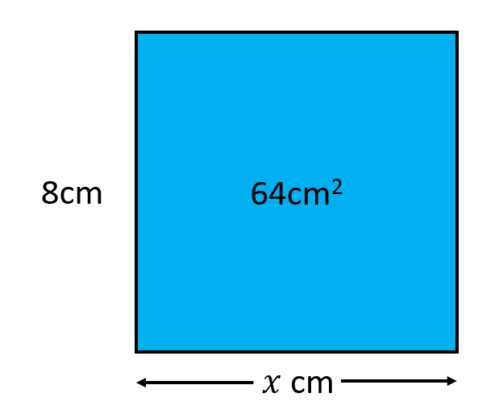
2. 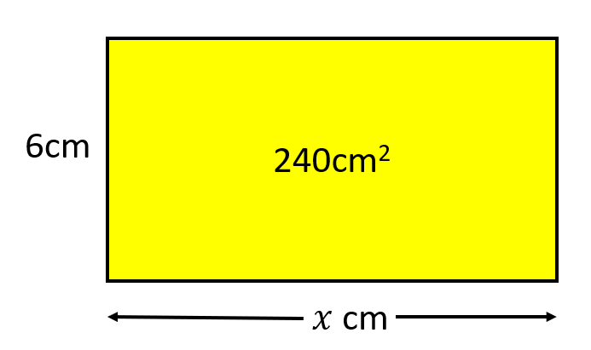

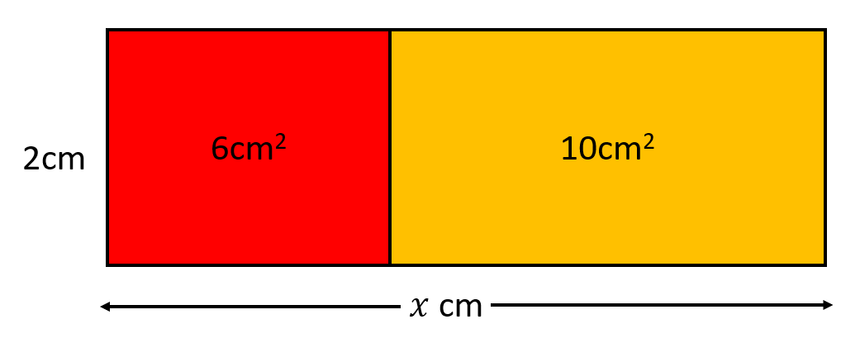

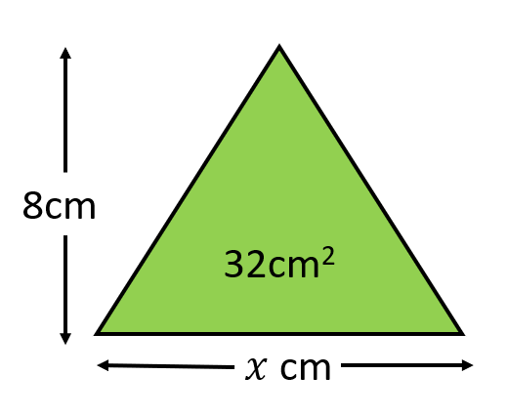

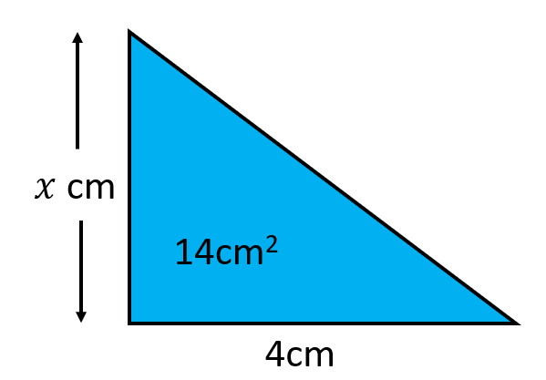

1. Find *y* and then *x*.

Green and blue rectangles side by side and share the same length. The green rectangle is labelled 10 cm squared, it has a width of 5 cm and length of y cm. The blue rectangle is labelled 25 cm squared and has a length of y cm and width of x cm. Find y and then find x.


1. Find *y* and then *x*.

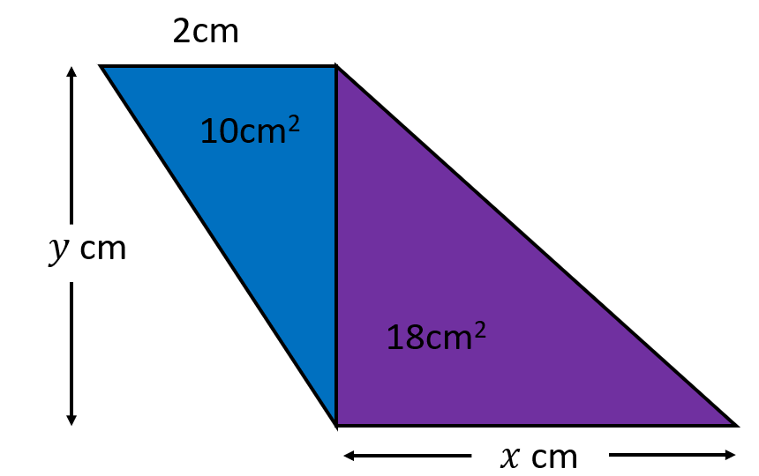

1. After you have found, *x*, find *y*.

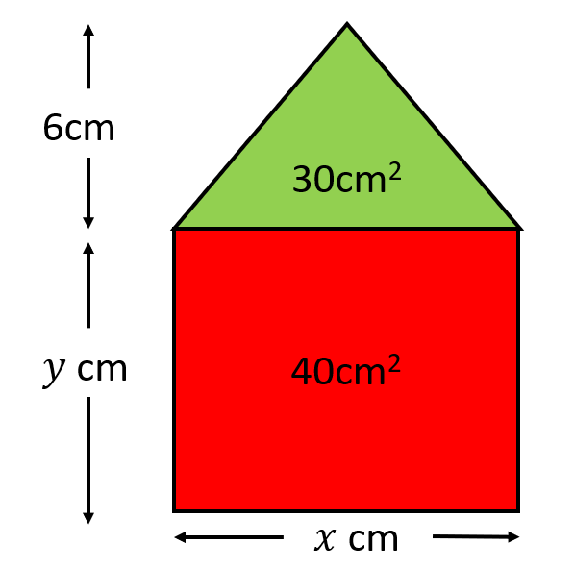

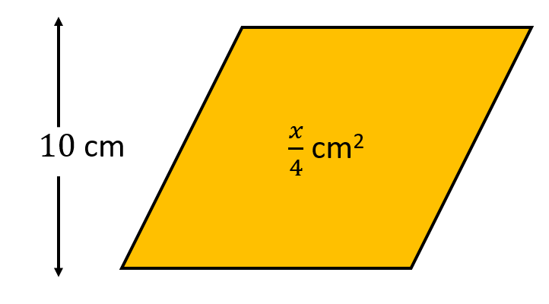

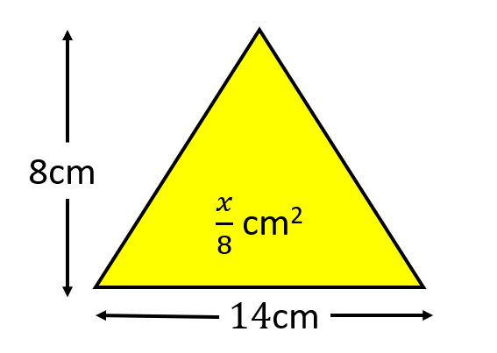

1. First find *x*, then find *y*.

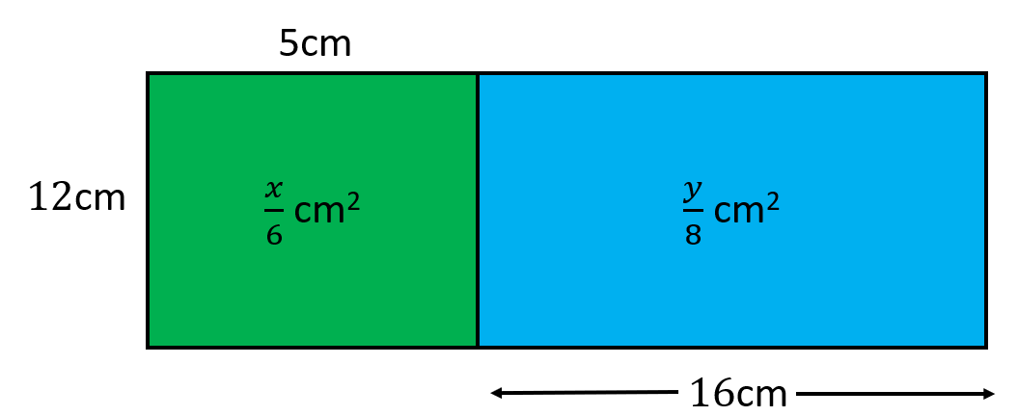

1. First find *y*, then *x*.

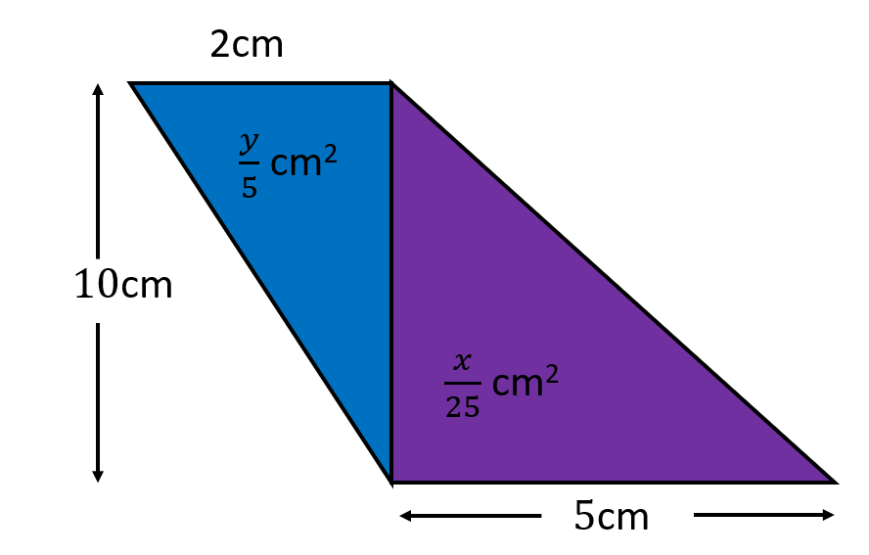

Algebra maze

Move through the maze from start to finish. Each equation is linked by two possible values for the unknown variable. Use arrows to show the direction that is correct to show the correct pathway to the end.

Diagram shows a maze or matrix of linear equations There are three rows of four equations. Between each equation both horizontally, vertically and diagonally are two or three possible alternative values  for substitution or pathway. Solve each equation substituting the values to decide which pathway to select to get to the next equation. The first row from left to write shows: 
x minus four equals 12, the value 16 going right, the value 8 going down. 
The next equation is 2 plus A equals 9, the value 11 going right, the value 1 going down, the value 7 going diagonally down to the left. 
The third equation is negative 3 equals w minus 2, the value negative 1 goes right, the value 5 goes diagonally down and to the right, the value negative 5 goes down, the value 3 goes diagonally down and to the left.  
The fourth equation is 5 equals y divided by 5, the value 1 going down. 
Starting from the left on the second row, the equation reads 2 equals x divided 3, negative 1 goes to the right, the value 6 goes down. 
2 minus z equals negative 1, the value 5 goes to the right, negative 3 goes down, the value 5 goes diagonally down and to the left. 
4 equals negative 1 minus k, the value 5 goes to the right, the value 4 goes diagonally down and to the right, negative 3 goes down, negative 5 goes diagonally down and to the left.
20 equals 4 multiplied by R, the value 4 goes down. 
The final row from the left shows equation 9 P equals 45, zero to the right. 
2 = n minus 2, the value 4 to the right, h divided by negative 3 equals negative 1, the value 3 to the right, x divided by 4 equals 12 end.

Algebra maze: solution

Diagram shows a maze or matrix of linear equations There are three rows of four equations. Between each equation both horizontally, vertically and diagonally are two or three possible alternative values  for substitution or pathway. Solve each equation substituting the values to decide which pathway to select to get to the next equation. The first row from left to write shows: 
x minus four equals 12, the value 16 going right, the value 8 going down. 
The next equation is 2 plus A equals 9, the value 11 going right, the value 1 going down, the value 7 going diagonally down to the left. 
The third equation is negative 3 equals w minus 2, the value negative 1 goes right, the value 5 goes diagonally down and to the right, the value negative 5 goes down, the value 3 goes diagonally down and to the left.  
The fourth equation is 5 equals y divided by 5, the value 1 going down. 
Starting from the left on the second row, the equation reads 2 equals x divided 3, negative 1 goes to the right, the value 6 goes down. 
2 minus z equals negative 1, the value 5 goes to the right, negative 3 goes down, the value 5 goes diagonally down and to the left. 
4 equals negative 1 minus k, the value 5 goes to the right, the value 4 goes diagonally down and to the right, negative 3 goes down, negative 5 goes diagonally down and to the left.
20 equals 4 multiplied by R, the value 4 goes down. 
The final row from the left shows equation 9 P equals 45, zero to the right. 
2 = n minus 2, the value 4 to the right, h divided by negative 3 equals negative 1, the value 3 to the right, x divided by 4 equals 12 end.