Mystery birds
The tables show the migration paths of three ospreys.
Where does each bird end their migration journey?
Choose a mystery bird. Plot its pathway on the map using the latitude and longitude.
Mystery bird 1 | Date | Latitude | Longitude
MB1 | 8/09/2022 | 55° N | 3° W
MB1 | 9/09/2022 | 52° N | 3° W
MB1 | 10/09/2022 | 50° N | 5° W
MB1 | 12/09/2022 | 45° N | 8° W
MB1 | 9/10/2022 | 43° N | 8° W
MB1 | 23/11/2022 | 41° N | 8° W
MB1 | 24/11/2022 | 40° N | 8° W
MB1 | 25/11/2022 | 34° N | 12° W
MB1 | 6/12/2022 | 27° N | 12° W
MB1 | 31/12/2022 | 27° N | 13° W

Mystery bird 2 | Date | Latitude | Longitude
MB2 | 26/08/2022 | 53° N | 2° W
MB2 | 27/08/2022 | 50° N | 3° W
MB2 | 29/08/2022 | 52° N | 8° W
MB2 | 30/08/2022 | 51° N | 10° W
MB2 | 31/08/2022 | 51° N | 9° W
MB2 | 1/09/2022 | 52° N | 10° W
MB2 | 25/08/2022 | 55° N | 3° W
MB2 | 28/08/2022 | 49° N | 9° W
MB2 | 4/09/2022 | 52° N | 9° W

Mystery bird 3 | Date | Latitude | Longitude
MB3 | 24/08/2022 | 55° N | 3° W
MB3 | 25/08/2022 | 52° N | 2° W
MB3 | 26/08/2022 | 51° N | 3° W
MB3 | 27/08/2022 | 46° N | 9° W
MB3 | 28/08/2022 | 40° N | 9° W
MB3 | 29/08/2022 | 40° N | 8° W
MB3 | 1/09/2022 | 41° N | 8° W

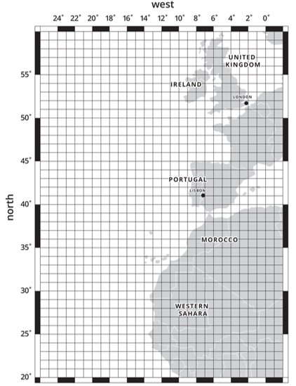
Source: Google maps
Where did your mystery bird end its journey?

