Fruit fractions: Gardeners of fractions
Year level  Strand(s)  Lesson length  CD Code | - Year 3/4  - Number  - 60 mins  - AC9M3N02  - AC9M4N03
Lesson summary | In this lesson, students use a simulated garden bed to explore tenths. They explore fractions within simulated Asian gardening plots. They draw garden beds, allocate fractions to fruit plants, and combine fractions to understand tenths. Through creativity and discussion, they grasp the concept of fractions as parts of a whole and end with a fun Dice fraction game.
Learning intention | - We are learning to represent tenths as fractions within a simulated garden bed and can comprehend the allocation of fractions to different fruit plants. We understand the concept of combining fractions to make a whole.  - We are learning to create visual representations of fractions and articulate/share our understanding of fractional quantities with my peers.
Success criteria | By the end of this lesson, students can:  - use mathematical language to describe how fractions are used in practical contexts  - create visual representations of fruit fractions within simulated garden beds involving tenths.
Why are we learning about this? | By grasping the concept of fractions, you’ll unlock your ability to distribute your preferred fruits in a fair manner within the simulated garden plots. Fractions are fundamental tools in mathematics and support real-life applications like cooking and budgeting as well as fostering part-whole relationships.
Prerequisite student knowledge and language | Students have:  - basic arithmetic skills (addition, subtraction and multiplication)  - some familiarity with common colours/fruits is useful.
Resources | - Teacher’s slides (PowerPoint)  - Coloured pens/pencils  - Grid paper (or regular paper)  - 10-sided dice
Curriculum information
Achievement standard | Students represent unit fractions and their multiples in different ways.  They recognise equivalent fractions and make connections between fractions and decimal notation. Students count and represent fractions on a number line.
Content description(s) | - Students recognise and represent unit fractions including $\frac{1}{2}, \frac{1}{3}, \frac{1}{4}, \frac{1}{5}$ and $\frac{1}{10}$and their multiples in different ways; combine fractions with the same denominator to complete the whole. AC9M3N02  - Students find equivalent representations of fractions using related denominators and make connections between fractions and decimal notation. AC9M4N03
General capabilities  Cross-curriculum priority | General capabilities  Literacy:  - Speaking and listening (P4)  Numeracy:  - Interpreting fractions (P4)  - Number and place value (P6)  Cross-curriculum priorities  - Asia and Australia's Engagement with Asia: Knowing Asia and its diversity (AAK1)
Areas of challenge | Some students may:  - struggle with grasping the concept of fractions within the context of Asian gardening plots, particularly if they have limited prior exposure to this mathematical concept  - be challenged by the introduction of fraction-related terminology such as ‘tenths’, as this may be somewhat abstract for certain students, potentially leading to confusion or difficulty in using precise mathematical language  - encounter challenges visualising and representing tenths as fractions, as the specific shapes and sizes of garden bed sections allocated to different fruits may vary.
Strategies | Explicit teaching  Classroom talks  Concrete, Representational, Abstract model (CRA)

Lesson structure
Learning hook  15 mins | Use the teacher’s slides to support your teaching.  Warm-up challenge:  Always, sometimes, never  - Show image from slide 1. Students work in a small group to justify whether a numerator is ‘always, sometimes or never’ smaller than the denominator. Groups present their answers to the class.  - Expect responses such as: ‘always’ because that is the only experience students have – introduce $\frac{5}{4}$ pieces of pizza.  Differentiation (extension): Have the student list some examples.  Differentiation (support): Teacher to show/model examples for students.  Begin the lesson by sparking interest in Asian gardening and the concept of planting fruits in garden beds, connecting it to the students' everyday experiences of gardens. Share a brief Asian gardening anecdote or showcase images of various Asian garden fruits. (Show the example Planting Asian fruit trees, Asian fruits on slides 3, 4 and 5.)
Explore  30 mins | - Distribute drawing paper or pre-made garden bed templates to students. Ask them to design an Asian-inspired garden bed consisting of 10 squares (2 $×$5):  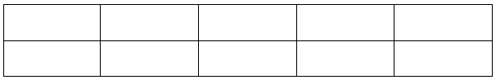  - Encourage creativity in the borders/outsides of their garden bed designs, drawing inspiration from the beauty of Asian gardens.  - Explain that they will be selecting and drawing different Asian fruits in their garden beds. Reshow images of unique Asian fruits (slides 3 and 4) to inspire their choices. Let each student choose one or more Asian fruits to include in their garden bed design.  - Let students know that each square in their garden bed represents a fraction of the whole garden. For instance, if they draw a dragon fruit in one square, it signifies $\frac{1}{10}$ of the garden will be dedicated to dragon fruit, emphasising the concept of tenths.  - Have students draw their chosen Asian fruits in the squares of their garden beds, representing the fractions they discussed. For example, if they select lychees, they might draw 2 lychees in 2 squares, representing $\frac{2}{10}$ or $\frac{1}{5}$ of the garden bed is devoted to lychees.  Classroom talks: Fraction discussion  Gather the students to discuss what they've drawn and the fractions they used in their garden designs. Ask questions such as, ‘How much of your garden is dedicated to mangoes? How about durians?’ Ensure students understand that when combined, the fractions should equal 10 tenths – a whole garden.
Brain break
Which One Doesn’t Belong? (WODB)
- Host a discussion about which one of these fractions ‘doesn’t belong’. (Hint: any answer can be correct – the justification is the important part.) Expect answers such as ‘$\frac{1}{2}$ because all the rest are tenths’, ‘$\frac{1}{10}$ because all the rest are half or more’, ‘$\frac{10}{10}$ because all the rest are half or less or because in all the others the numerator is less than the denominator’.
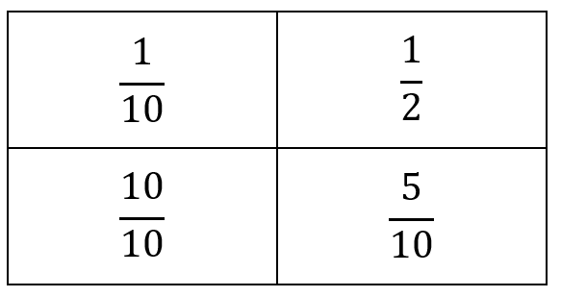

Explicit teaching: Decimal notation
- After the Asian garden bed fractional drawing activity, introduce the concept of decimal notation as an alternative way to represent fractions. For example, $\frac{1}{10}$ can be written as 0.1 in decimal notation.
- Ask students to take their garden bed designs and represent the fractions they've drawn using decimal notation. For example, if they had drawn $\frac{2}{10}$ for lychees, they should now represent it as 0.2 in one of the squares.
- Provide guidance to ensure students understand how to convert fractions into decimals and encourage them to annotate the decimal representations of their garden beds.
- Discuss their garden bed designs with decimal notations, asking questions like, ‘What is the decimal representation for the fraction $\frac{3}{10}$ in your garden bed?’ Emphasise that the sum of all decimal fractions in their garden bed should equal 1.0, representing the entire garden.
Optional: Students use Excel (or Word tables) to re-create their own Asian garden in a digital version.
Differentiation (extension): Challenge students to work with a 10$×$10 grid, or alternatively a 10$×$2 grid; represent equivalent fractions; represent using hand-drawn arrays; link with other denominators, for instance, ‘Are any of your gardens more than half ‘x’ fruit?’
Differentiation (support): Students work with a garden plot 2$×$2 or only 2 different fruits.
(CRA) model: This lesson moves from using representation when drawing the garden to abstract when writing the proportions of the different fruits as fractions and decimals.
Summary and reflection  15 mins | Summarise the lesson's key points and invite students to reflect on what they've learned:  - ‘What do you now know about fractions, in particular tenths?’  - ‘Can you explain the difference between a numerator and a denominator?’  - ‘How are common and decimal fractions linked?’  - ‘How can you use fractions in everyday situations?’
Assessment | The following activity is suggested for an informative way to track student progress.  If time allows at the end of the lesson, use the Exit ticket from the teacher’s slides to play the Dice fraction game.  - State the fruit.  - Roll a 10-sided dice.  - Students colour the number rolled as tenths to represent that fraction in their garden bed.  Expect responses such as, students colouring a garden bed with two separate colours.

