Exit slip
Name:  Sam made 3 mistakes when he created this  stem-and-leaf plot.  How many can you find?  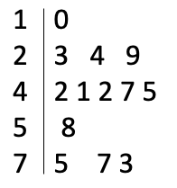 | Mistakes:  1)  2)  3)
Name:  Sam made 3 mistakes when he created this  stem-and-leaf plot.  How many can you find? | Mistakes:  1)  2)  3)
Name:  Sam made 3 mistakes when he created this  stem-and-leaf plot.  How many can you find? | Mistakes:  1)  2)  3)

