Solving equations: shapes worksheet
Consider each shape and write an equation for each. The area formulas for rectangles, triangles and parallelogram are also given.

Formulas
Area of a rectangle = length × width
Area of a triangle = $\frac{1}{2}$ × base × height
Area of a parallelogram = base × height

- 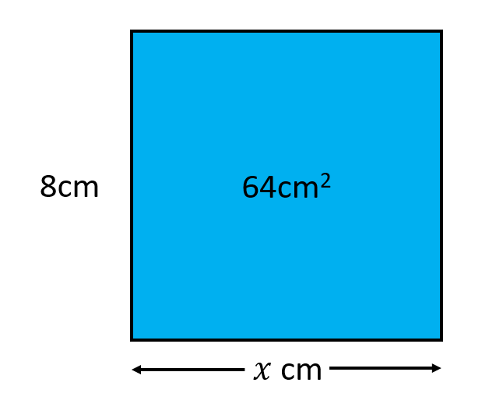
- 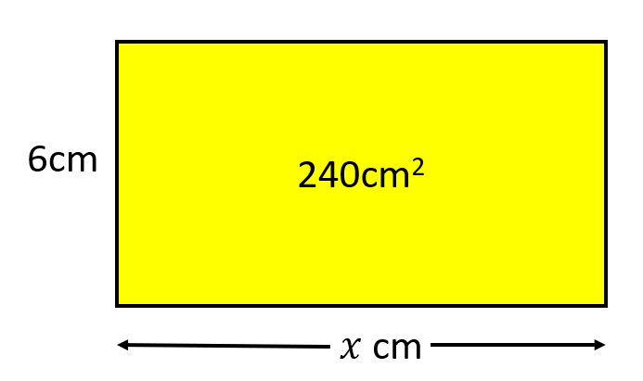

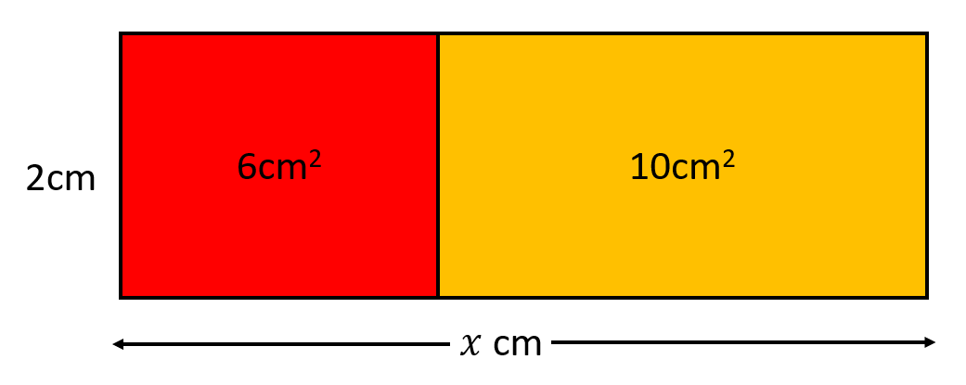

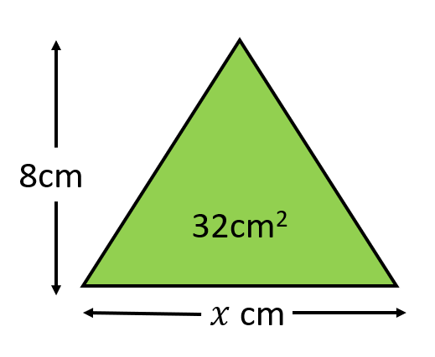

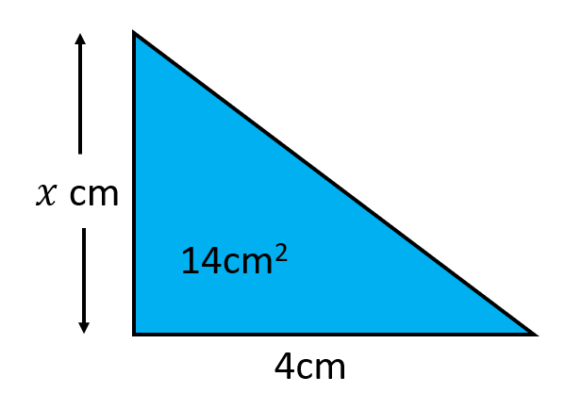
- Find y and then x.
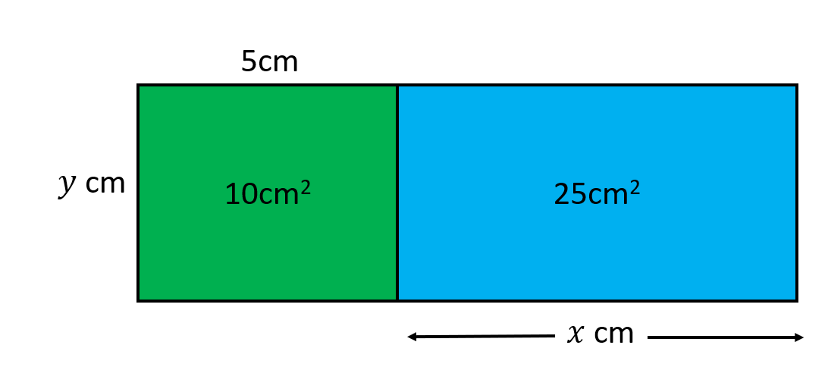
- Find y and then x.
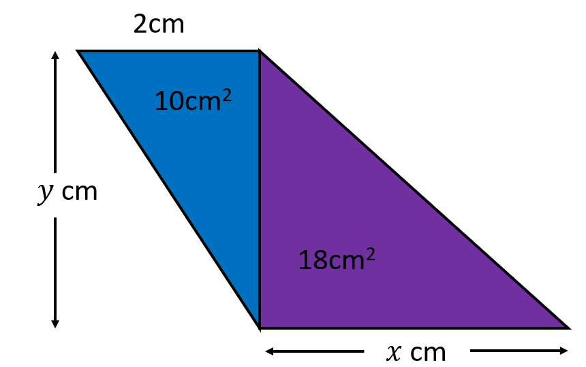

- After you have found, x, find y.

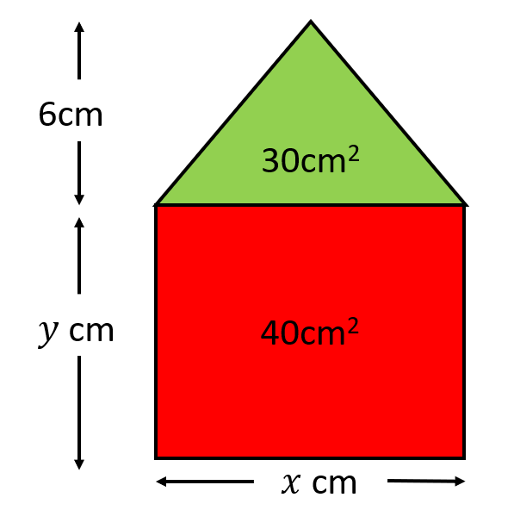

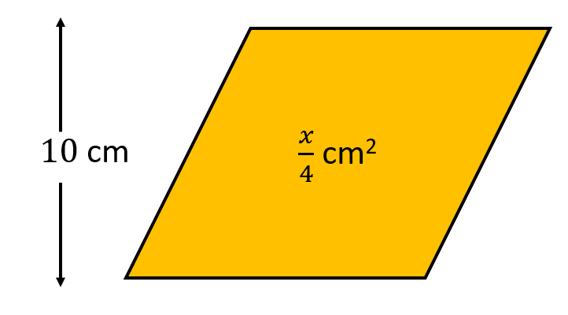

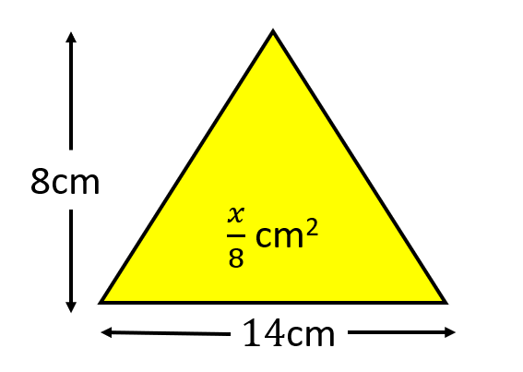
- First find x, then find y.

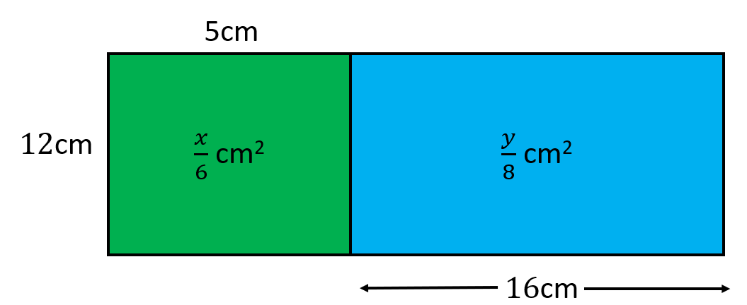
- First find y, then x.
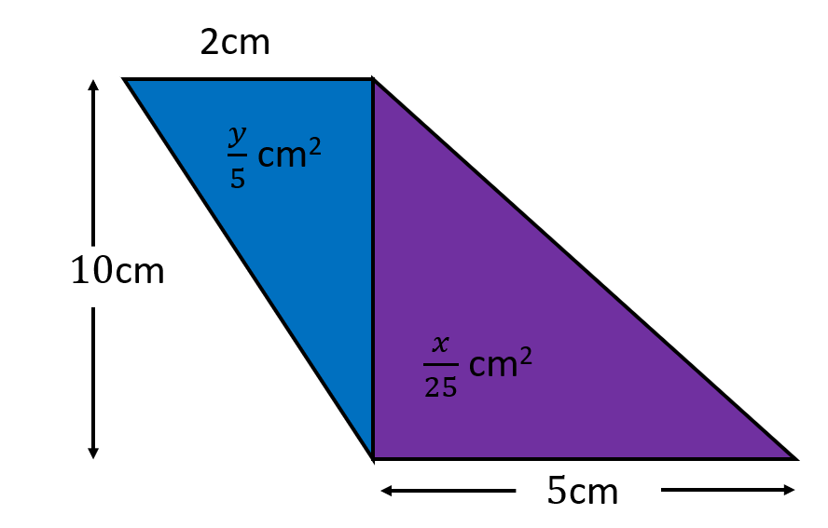

Algebra maze
Move through the maze from start to finish. Each equation is linked by two possible values for the unknown variable. Use arrows to show the direction that is correct to show the correct pathway to the end.
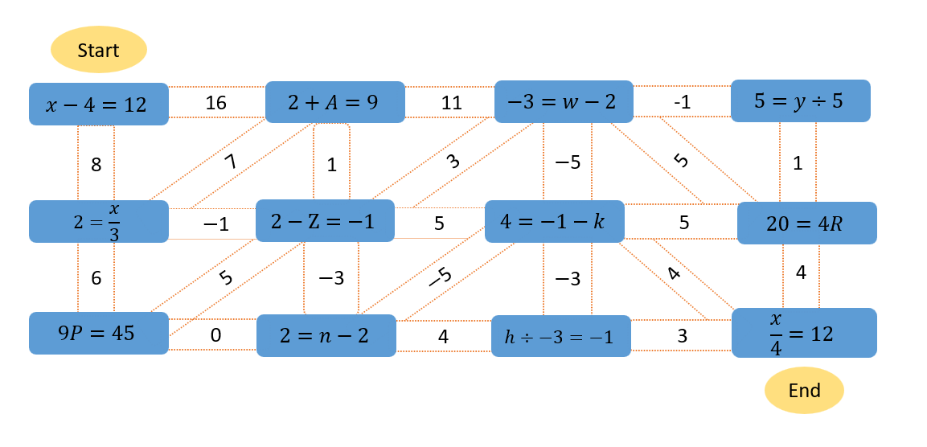

Algebra maze: solution

