Name:

Class:

Geometric assessment

Instructions
If you know the size of the angles a and b, how many other angles can you determine?
Use geometric reasoning with terminology to explain how you can determine each angle. There are templates of these shapes as well as space on the next page to explain your reasoning.
You may wish to use coloured markers or pencils to help communicate your results clearly.
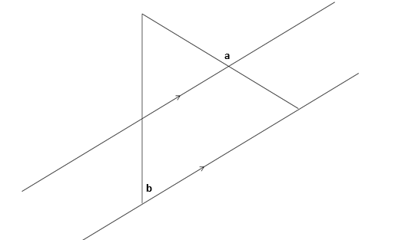
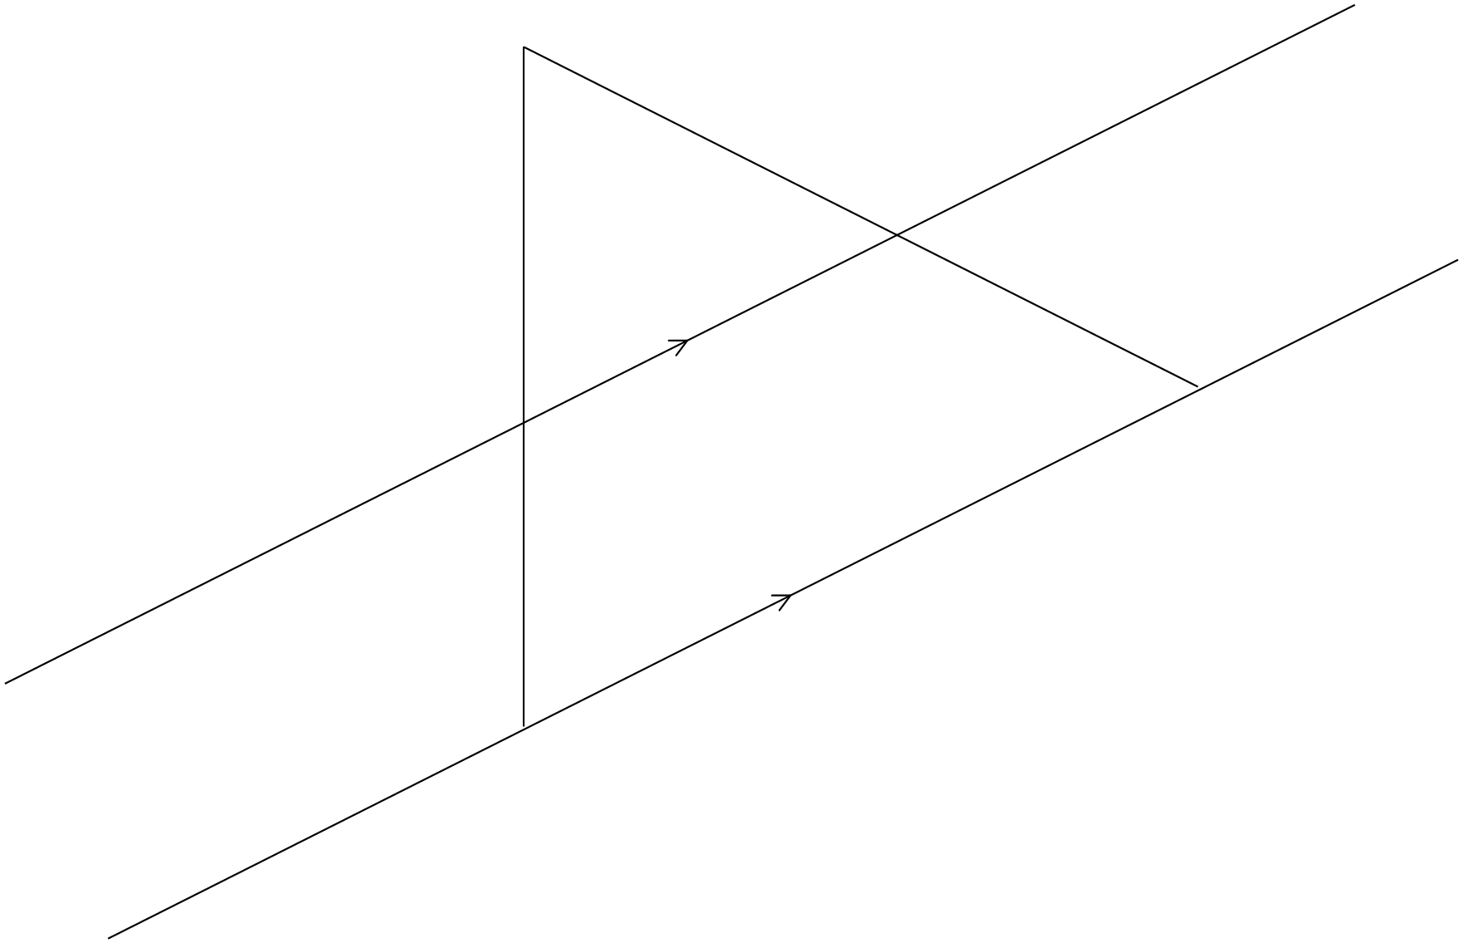

In summary, my findings are:

