Fruit fractions: Growing with fruit
Year level  Strand(s)  Lesson length  Code | - Year 4  - Number  - 60 mins  - AC9M4N03  - AC9M4N04
Lesson summary | Explore fractions through plant growth in this engaging lesson. Embark on a journey into the world of fractions through the growth of garden plants. Students will measure and represent plant growth using fractions, gaining a clear understanding of numerators and denominators. This interactive lesson encourages creative exploration of equivalent fractions while fostering a deeper connection with the concept of fractions in the context of gardening.
Learning intention | - We can recognise and represent fractions, including halves, quarters and eighths, through plant growth activities, gaining a clear understanding of numerators and denominators.  - We can explore and apply my knowledge of fractions to identify and create equivalent fractions while investigating plant growth and the visual distinctions between fractions like halves, quarters and eights through simulated a simulated plant growth activity.
Success criteria | By the end of this lesson:  - students can explain, using appropriate mathematical vocabulary, the practicality of fractions in the context of plant growth and gardening, and how they are applied in real-life scenarios  - students can create visual representations of plant fractions, including equivalent fractions to demonstrate their understanding of fractions in the context of gardening.
Why are we learning about this? | Fractions play a crucial role in understanding and applying mathematics to the real world. Imagine having a garden with various plants of different heights. Have you ever wondered how to measure and track their growth accurately? In this lesson, we'll explore fractions in the context of gardening. By mastering fractions, you'll learn how to measure and predict plant growth.
Prerequisite student knowledge and language | It is expected that students have:  - basic arithmetic skills (addition, subtraction, and multiplication) to work with fractions and measurements in the context of gardening  - some prior familiarity with common garden plants and their growth patterns is useful but not mandatory.
Resources | - Teacher’s slides (PowerPoint)  - Equivalent Fraction matching game (PDF)  - Student exercise books  - Rulers, scissors  - 1cm grid paper (optional)  - Seedlings, or access to a garden (optional)
Curriculum information
Achievement standard | Students recognise equivalent fractions and make connections between fraction and decimal notations. Students count and represent fractions on a number line.
Content description(s) | Students find equivalent representations of fractions using related denominators and make connections between fractions and decimal notation. AC9M4N03  Students count by fractions including mixed numerals; locate and represent these fractions as numbers on number lines. AC9M4N04
General capabilities  Cross-curriculum priority | General capabilities  Literacy:  - Speaking and listening (PL5)  Numeracy:  - Interpreting fractions (PL5 and PL6)  - Number and place value (PL7)  Cross-curriculum priorities  - Sustainability: All life forms, including human life, are connected through Earth’s systems (SS1)
Areas of challenge | Some students may:  - find it challenging to grasp the fundamental concept of fractions, especially if they haven't been exposed to it before  - find the introduction of terms like ‘numerator’ and ‘denominator’ can be a bit abstract for younger students – students may confuse these terms  - find understanding equivalent fractions, where different representations equal the same amount, can be challenging for students, as it requires abstract thinking and the ability to visualise fractions in various forms within the context of plant growth.
Strategies | Explicit teaching  Questioning  Differentiated teaching
Lesson structure
Introduction  10 mins | Note: Use the teacher’s slides to support teaching this lesson. Pre-prepare the Equivalent fraction matching game by printing enough for the class. The game is played later in the lesson.  Warm-up challenge  Who is right?  - Jordan believes that $\frac{3}{8}$ is bigger than $\frac{1}{2}$. Taylor believes it is smaller. Who is right? (slide 1)  Students use mini-whiteboards or their maths book to choose ‘Jordan’ or ‘Taylor’ and justify their answer using mathematical language.  - Expect responses such as: Jordan is right because I have a friend ‘Jordan’ and s/she's always right; Jordan's right because 3 and 8 are bigger numbers.  - Rate the responses – gather or annotate some students’ answers. Have a class discussion as to what constitutes a half (two equal parts) and what are the equivalent fractions of $\frac{1}{2}$. Further questioning includes: ‘if $\frac{4}{8}$ is the same as $\frac{1}{2}$, how can we prove $\frac{3}{8}$ is smaller?’  Differentiation (extension) – ‘If Jordan ate $\frac{3}{8}$ of a pizza, and Taylor ate $\frac{1}{2}$, how much is left over? Prove it’.  Differentiation (support) – ‘Jordan believes $\frac{3}{4}$ is bigger than $\frac{1}{2}$. Taylor believes it is smaller. Who is right?’
Learning Hook  10 mins | - Begin with an engaging discussion about the importance of understanding fractions in everyday life.  - Display images of various fruits from the first slide with a focus on native Australian fruits like quandong and finger lime, sparking curiosity about their taste and origin (slide 2).  - Ask students where fruit comes from (slide 3). Discuss/show the various types of fruit plants. Move to the next slide and refer to Plant life cycle.
Explore  30 mins | - Instruct students to draw an imaginary fruit plant that is 8cm tall. The plant starts as a seed but every day the plant grows 1cm taller. On Day 1, explain that it's grown to 1cm which is $\frac{1}{8}$ of its full height, and have students draw what it would look like at that size. Repeat this for Day 2 $\left(\frac{2}{8} \right)$, Day 3 $\left(\frac{3}{8} \right)$, Day 4 $\left(\frac{4}{8} \right)$and so forth. Illustrations are provided in the appendix.  - Track this growth in a table as you go:  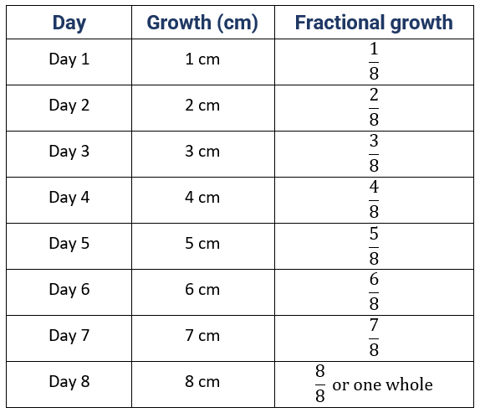  - Number Line: track this growth on a vertical number line. Emphasise that the number line helps us understand fractions better.  - Introduce equivalent fractions, for example, Day 4 is in the middle $\left(\frac{4}{8}=\frac{1}{2}\right)$ and the plant is half its full height and similarly for $\frac{2}{8}=\frac{1}{4}, \frac{6}{8}=\frac{3}{4}$ and $\frac{8}{8}=1$ whole.  - Refer to the slides 5 and 6 to aid discussion and student understanding.  - In pairs, students play equivalent fraction matching game (slide 7). Students cut out different images/words/fractions and match them in groups. The blank cards are for students to draw their own image to complete the set.  Discussion  - Encourage students to compare the fractions they've drawn. Ask questions like, ‘Is $\frac{3}{8}$ bigger or smaller than $\frac{5}{8}$ ?’ This helps build a basic understanding of comparing fractions.  - Discuss the measurements and fractions. Ask questions like, ‘How much has your plant grown since the beginning?’ ‘Is your plant more or less than $\frac{3}{4}$ grown? How do you know?’ Encourage them to explain their fractions and measurements.  Deepening the knowledge  - Repeat the activity, but this time instruct students to draw an imaginary plant that is 10 cm tall and grows 1 cm every day.  - Explain that this time the number line has been divided into tenths not eighths.  - Help students understand the relationship between fractions and a whole. For example, $\frac{1}{2}$ of 10 is 5; however, $\frac{1}{2}$ of 8 is 4.  - Introduce and link fractional to decimal representation; that is, $\frac{3}{10}=0.3, \frac{10}{10}=1$.  Differentiation (extension): Challenge advanced students to explore different ways to visually represent equivalent fractions for the plant's growth (for example, $\frac{2}{10}$ can be shown in multiple creative ways); ‘What would it look like at $\frac{1}{4}$ of its full height? When would it reach $\frac{3}{4}$ of its full height?’  Differentiation (support): For students who may struggle with fractions, provide concrete objects like rulers or measuring tools to help them visualise and understand the concept of plant growth fractions.
Summary and reflection  10 mins | Summarise the key points of the lesson by reminding students about the plant growth and how they used fractions to represent it. Highlight the importance of understanding fractions in everyday life.  Reflection questions  Invite students to reflect on what they've learned and their experiences with fractions and plant growth:  - ‘What did you find most interesting about using fractions to represent plant growth?’  - ‘What have we learned about number lines today?’  - ‘How can you imagine using fractions in everyday situations, like measuring plant growth or sharing something with friends?’
Assessment | The following items below are suggested for formative assessment for this lesson.  Preserve time at the end of the lesson for students to reflect and demonstrate their learning. Utilise ‘Exit Ticket’ in slide 9 from the teacher’s slides.  - Students will stand behind their desk and stand on tiptoes with arms spread out- this is to represent them as a ‘whole plant’  - They then curl up in a little ball on the floor to represent a seed.  - The teacher gives increments of fractions (for example, ‘You are now $\frac{1}{10}$ fully grown’ ‘You are now $\frac{1}{4}$ fully grown’.  - The students follow these increments by ‘growing’ until they are finally a ‘whole’ plant.  - Repeat the activity with students in pairs taking turns giving each other instructions on how to ‘grow’.  Expect responses such as: Students 'grow' to half very quickly before slowing down (students think that half is larger than it is). It is very hard to grow a small amount like a $\frac{1}{10}$.

Explore/investigate equivalent fraction matching game
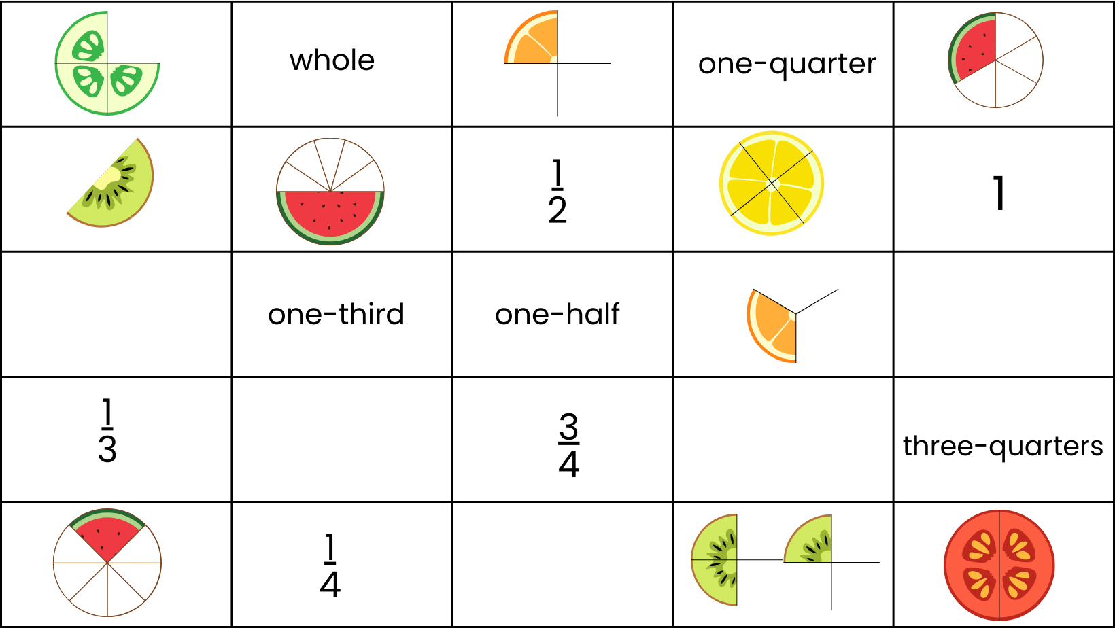
Explore/investigate equivalent fraction matching game – solution
