Numeracy across the learning areas (Foundation to Year 6)

Professional learning session: Facilitator guide

Aim
This professional learning is designed to:
- help primary school teachers develop a shared understanding of how numeracy links to non-maths learning areas of the Australian Curriculum
- assist teachers to become familiar with the Numeracy progression as a tool for identifying numeracy skills.

Activities
The session includes a main activity, where participants identify opportunities for numeracy learning by focusing on a non-maths learning area and linking learning area content descriptors and elaborations to the Numeracy progression.

Suggested duration
1 hour. Alternatively, the session could be spread across two 45-minute sessions or a single 90-minute session to enable richer exploration and discussion.

Supporting resources
For facilitator use:
- Slide deck with guidance notes. The facilitator can adapt the slides and session to suit the school context.
- Appendix 1: Key connections examples
- Appendix 2: Australian Curriculum V9 site navigation
For participants:
- Resource 1: Key connections cards detailing numeracy links for a variety of learning areas and year levels to suit the needs of the session participants
- Resource 2: Activity 2: Curriculum jigsaw card sets

Introduction

Duration
5 minutes
Welcome the participants and display the slide deck. Explain that this PL could be used as a springboard for co-designing a whole-school curriculum plan, mapping links between scope and sequences for mathematics and non-maths learning areas.
Slides 1 to 2: Refer to the slides to explain the learning intentions for the session.
Slide 3: Reflective questions entry ticket. Teachers rate the statements on the slide on a scale from 1 to 5. The ratings will be returned to at the end of the session.
Slides 4 to 6: Share and discuss the definitions of numeracy and numeracy learning.

Activity 1: Key connections

Duration
15 minutes

Materials
Resource 1: Key connections cards; highlighters

Task
Slide 7: Print and distribute: Resource 1: Key connections cards. Teachers use the cards to identify how numeracy can be developed within each learning area to deepen student engagement. Use the Key connections examples (Appendix 1) to assist in the discussion.
For facilitator reference:
- Appendix 1: Key connections examples provides an example of Key connections for each learning area.

The Numeracy learning progression

Duration
5 minutes

Slides 8 to 10: Explore the Numeracy learning progression and demonstrate how teachers can navigate the AC website.
For facilitator reference:
- Appendix 2: Australian Curriculum V9 site navigation provides a step-by-step guide to navigating the AC website which the facilitator can use to demonstrate to teachers.

Activity 2: Curriculum jigsaw

Duration
30 minutes

Materials
Resource 2: Activity 2: Curriculum jigsaw card sets.
- The Activity 2: Curriculum jigsaw card sets detail numeracy links for a variety of learning areas and year levels to suit the needs of the session participants.
- Decide which sets of resource cards to provide for each group and have them cut up and ready for groups to explore.

Task
Slide 11: Teachers use the Curriculum jigsaw cards to explore the connections between content descriptors, elaborations and Numeracy learning progression extracts.
Slide 12: Teachers report their findings back to the group.

Exit task

Duration
5 minutes
Slide 13: Teachers return to the Reflective questions from the beginning of the session.

For facilitator use
Appendix 1: Key connections examples
Learning area | Numeracy opportunities
English | - Reading and evaluating quantities, statistics, patterns  - Presenting evidence and substantiating ideas  - Bias in numerical data and quantitative sources
HASS | - Count and measure data  - Construct and interpret tables and graphs  - Calculate and interpret statistics  - Time: scaled timelines (positive and negative numbers), calendars, dates  - Data: surveys, field tests  - Maps, models, diagrams – grids scale, distance, area, projections
HPE | - Calculations, estimation, measurement – nutrition, fitness, navigation, skills  - Spatial reasoning – movement  - Statistical reasoning – interpret and analyse  - Data patterns and relationships – trends, conclusions predictions
Languages | - Numbers e.g. time, direction  - Measurement – money  - Units of measurement – number volume, weight  - Pattern – grammatical and syntactic rules
Science | - Scale, measurement, patterns, order, organisation  - Measurement and data collection  - Data patterns  - Representing data – tables, displays, visualisation  - Interpreting data  - Statistical analysis – validity and reliability of data
Technologies | - Calculate, estimate  - Statistics – interpret, draw conclusions  - Measurement  - Number, cost  - Geometry: scale, proportion  - Measurement and volume  - 3D models – technical drawings, digital models  - Computational thinking
The Arts | - Calculating and estimating  - Spatial reasoning – space, patterns, symmetry, 2D and 3D shapes  - Scale and proportion – position, pathways, movement  - Measurement – length, area, volume, capacity, time, mass, angles  - Data – diagrams, charts, tables, graphs, motion capture

Appendix 2: Australian Curriculum V9 site navigation
Example A: Year 10 HPE
- Go to: https://v9.australiancurriculum.edu.au/.
- Select F-10 Curriculum from the menu bar.
- Select Health and Physical Education and Year 10.
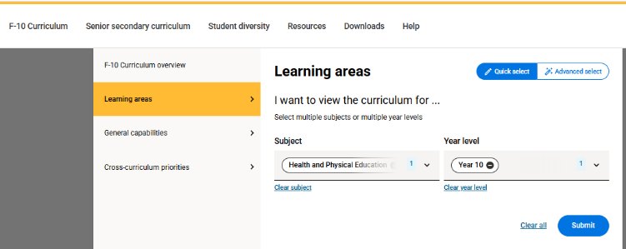
- Scroll down to AC9HP10P09: ‘Critique health information, services and media messaging about relationships, lifestyle choices, health decisions and behaviours to evaluate their influence on individual attitudes and actions’.
- Click on ‘Elaborations’.
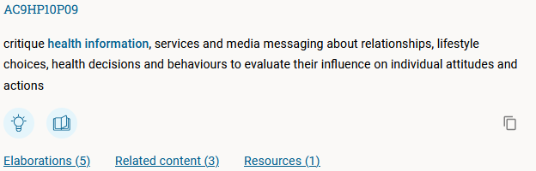
- Fold out the first elaboration.
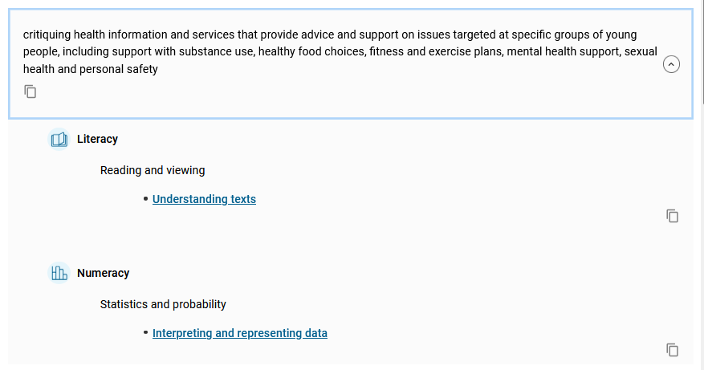

- Click on the ‘Interpreting and representing data’ link to view the flow from content description to progression description.

