Worksheet: Buying presents

Wally wants to buy a present for each of his nieces and nephews. He has two nieces and three nephews.
They are all between 10 and 12 years old.
He has a budget of $600.
He has narrowed it down to four items.
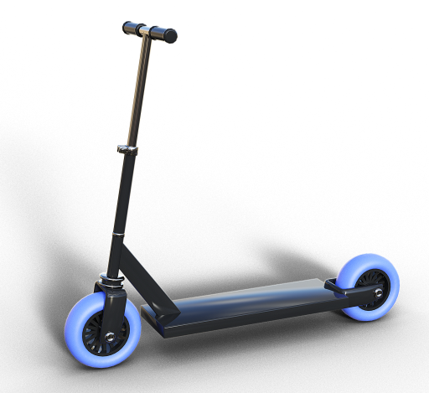  Scooter: $96 each |   Family board games: $65 each
  Basketball: $89 each | 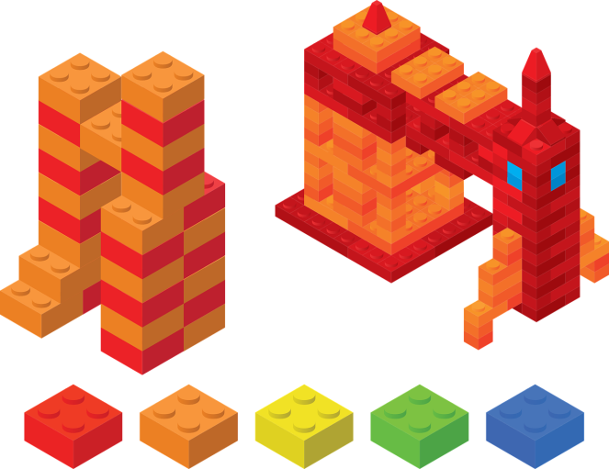  Building blocks kit: $109 each
- Record your ideas about how Wally could spend the money to buy the presents.
- Show how you might use rounding to estimate:
  - how many multiples of each item and you could buy for $600
  - how many different items you could buy for $600.
- List or draw some possible ways using your estimates.
- Show some ways Wally could spend the money to buy presents for his nieces and nephews.
- Model the different ways Wally could spend the money.
- Use a plan to organise your thoughts and select problem-solving strategies that are appropriate for the task.
- Show the steps you used and all your working out.
- Is there any money left over? If so, how much? Show your working out.
- What would you suggest Wally does with any left-over money?
Image source
https://pixabay.com/photos/family-game-game-board-game-588908/
https://pixabay.com/illustrations/scooter-children-scooter-locomotion-3128709/
https://pixabay.com/vectors/basketball-icon-ball-isolated-1731918/
https://pixabay.com/vectors/legos-toy-build-building-rocket-4338371/

