Workstation 1 instructions
Measure the dimensions of each of the shapes and record them in your workbook. Use the formulas for the area of a rectangle and area of a triangle to find the area of each shape.
b
h
l
w
$$Area of rectangle=length ×width$$
$=l×w$
$Area of triangle=\frac{1}{2}×base×heigh$t
$$=\frac{1}{2}×b×h$$

Mild
Measure the dimensions of shapes 1– 4 in centimetres and find the area.

Medium
Measure the dimensions of shapes 5– 8 to the millimetre (1 decimal place) and find the area (rounding your answer to 1 decimal place).

Spicy
- Measure the dimensions of shapes 1– 4 to the millimetre (1 decimal place) and find the area (rounding your answer to 1 decimal place).
- Then try at finding the area of the parallelogram (shape 9).

Hint
$$Area of parallelogram=base×height$$
$=b×h$

Workstation 1 shapes
1
2
3
4
5
6
7
8
9

Workstation 2 instructions
Measure the mass of each of the objects and record them in the table. Using the given volume of each object, use the formula below to calculate the density of each object. Make sure to record your workings when calculating the density.
$$Density=\frac{Mass}{Volume} =\frac{m}{V}$$

Mild
Complete the task as above. Order the objects from least to most dense.

Medium
Use a thousands MAB. Calculate its density.

Hint
You will first need to calculate its volume.
The volume of a cube is $V=length×width×height$

Spicy
Use a ones, tens, hundreds and thousands MAB. Calculate each of their densities.

Hint
You will first need to calculate its volume.
The volume of a rectangular prism is $V=length×width×height$

Object | Mass (m) | Volume (V) | Density
Pencil |  | 6.5cm³
Scissors |  | 30cm³
Ruler |  | 12cm³
Highlighter |  | 30.5cm³
Calculator |  | 128cm³
A4 Maths book |  | 349cm³
Pen |  | 6.5cm³

Workstation 3 instructions
- Mild
Consider the following scenario.
Milly is excited for her first job. Every week she earns $250. On top of that, she earns $1.50 for every hour she works on rainy days.
- Construct an equation that represents the total wages Milly will earn in a week.
- If one workday is 7 hours, find out how much Milly will earn for a week if it rains for:
1 day
2 days
3 days
4 days
5 days
- How much extra does Milly earn each day if it rains?

Hints
In your equation, you could use H for the number of hours it rains.
If one day is 7 hours, two days will be 14 hours, three days will be 21 hours …

Medium
Consider the following scenario.
Milly is excited for her first job. Every week she earns $250. On top of that, she earns 2 times the hourly rate for any overtime hours.
- Construct an equation that represents the total wages Milly will earn in a week.
- If Milly’s overtime rate is $40 per hour, what new equation can you write for Milly’s weekly earnings?
- If Milly’s overtime rate is $40 per hour, how much will she earn if she works:
1 hour overtime
2 hours overtime
4 hours overtime
8 hours overtime
- What do you notice about the difference in Milly’s weekly pay as her overtime hours increase?

Hint
In your equation, you could use H for the number of overtime hours, and R for the hourly rate for overtime.

Spicy
Consider the following scenario.
Milly is excited for her first job. Every week she earns $250. On top of that, she earns 1.5 times the hourly rate for any overtime hours.
- Construct an equation that represents the total wages Milly will earn in a week.
- If Milly’s overtime rate is $40 per hour, what new equation can you write for Milly’s weekly earnings?
- If Milly’s overtime rate is $40 per hour, how much will she earn if she works:
- 1 hour overtime
- 2 hours overtime
- 4 hours overtime
- 8 hours overtime
- What do you notice about the difference in Milly’s weekly pay as her overtime hours increase? On the graph, plot how Milly’s earnings increase as her overtime hours increase.

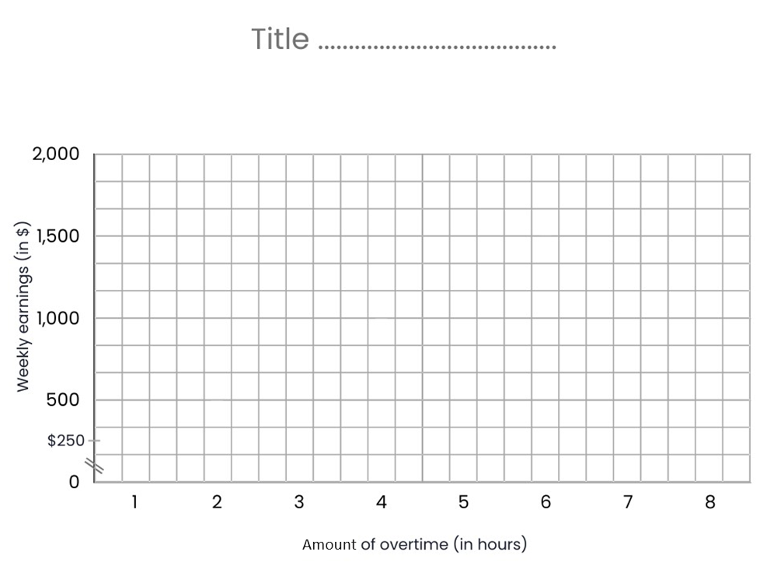

Workstation 4 instructions
The graph below shows how a rabbit population grows over time.
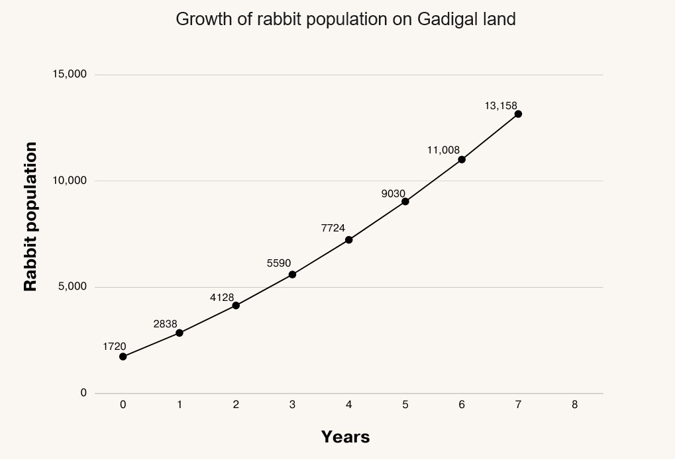

Mild
- Predict how many rabbits there might be after 8 years and explain why.
- What does the population at 0 years represent?
- When does the rabbit population exceed 9,000?
- The equation for the number of rabbits is:
$$Number of rabbits=86×\left(Y+10\right)×\left(Y+2\right)$$
$where Y$ represents the number of years.
  - Using this equation, how many rabbits are there at 1 year?
  - Does this match with the data from the graph?
- Using the equation above, how many rabbits are there at 3 years? Does this match the data in the graph?
- How reliable do you think the equation is? Explain your answer.
- What is the rabbit population at 8 years? How close was your estimation?

Medium
- Answer all the questions from ‘mild’.
- What will the rabbit population be after 100 years?
- Do you think this number is realistic? Why/why not?

Spicy
- Answer all of the questions from ‘mild’ and ‘medium’.
- At 8 years, predators (foxes) are introduced to the Gadigal rabbit population. From this year onwards, the population growth is represented by the equation:
$$Number of rabbits=86×(Y+10)×(Y-2)$$
Calculate the rabbit population for years 8, 9 and 10 and add these data points to the new graph.
- Has the new predator reduced the rabbit population effectively? Explain why.

Number of Rabbits | Year
1,720 | 0
2,838 | 1
4,128 | 2
5,590 | 3
7,224 | 4
9,030 | 5
11,008 | 6
13,158 | 7
 | 8
 | 9
 | 10

