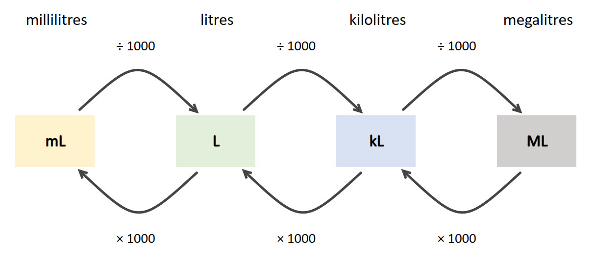
Converting from one unit of measurement to another

Steps | Thinking | Calculation
- Locate the units of measurement you have on the diagram. | 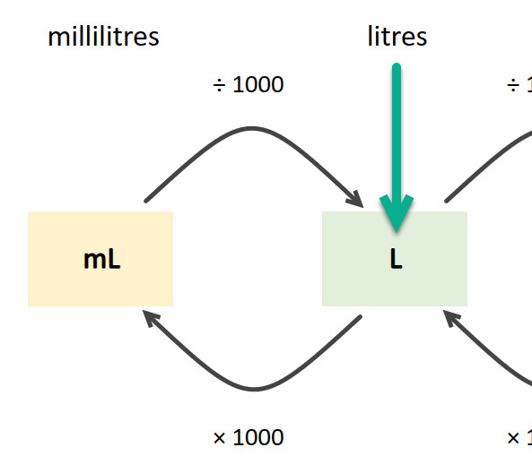 | I have 3.265 litres.
- Locate the units of measurement you want to convert to on the diagram. | 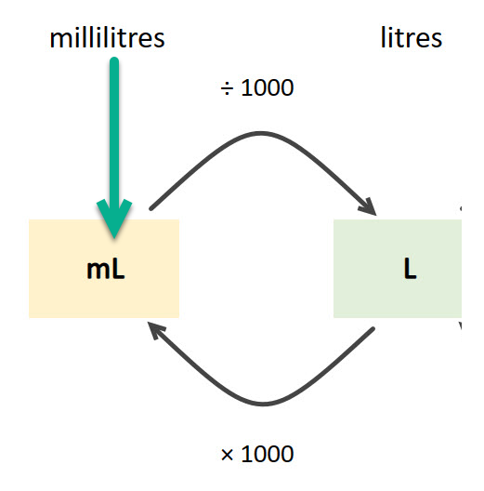 | I want to convert to millilitres.
- Which of the two arrows goes in the direction you are converting to? | 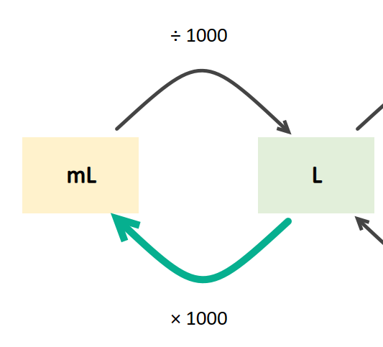 | The arrow is going from litres to millilitres (× 1000).
- Anticipate the answer. | Going from a larger unit of measurement to a smaller one | The number will be larger.
- Calculate the answer. | The digits will move 3 places to the left | 3.265 × 1000 = 3265 mL
- Check your answer, does it make sense? | 1 L is equivalent to 1000 mL | The answer makes sense.

