Lizard, Spock card cut-outs
Scissors   | Spock  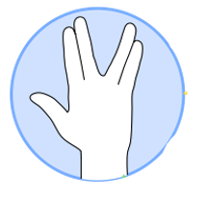 | Paper  | Lizard 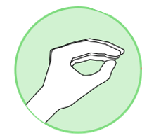 | Rock 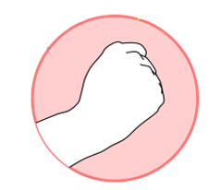
Scissors | Spock | Paper | Lizard | Rock
Scissors | Spock | Paper | Lizard | Rock
DMacks, CC BY-SA 3.0 via Wikimedia Commons

