Sleep diary instructions
- Fill out the sleep diary every night/morning.
- You will not be sure exactly when you went to sleep, so make an estimate.
- To calculate your Total sleep, find the difference between Time woke up next morning and Time went to bed. Multiply the number of hours
by 60 to convert to minutes and add on any other minutes.
- If you woke up during the night, don’t forget to subtract the Time awake in the night.
- Circle the emoji that best reflects your Mood in the morning:
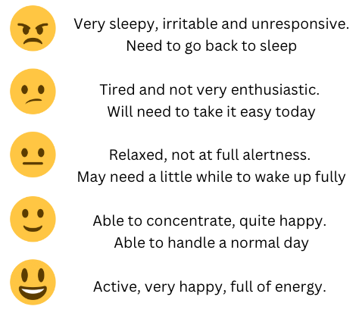
Week 2 instructions
In Week 2, make one change to follow every night that you think may increase your sleep. You might want to try:
- reading in bed
- not looking at any screens for 1 hour before going to bed
- setting a fixed bedtime
- having a shower at night.
- Continue your sleep diary for every night in Week 2.

Sleep diary – Week 1
Day and date | Time went to bed | What did you do in the hour before you went to sleep?  Tick all that apply | Time went to sleep | Time awake during night | Time woke up next morning | What woke you in the morning? | Total sleep  (in minutes) | Mood
 |  | ◻ Watched a show/movie  ◻ Talked to family/friends  ◻ On social media/gaming  ◻ Listened to music  ◻ Read a book |  |  |  | ◻ Woke myself  ◻ A family member  ◻ Alarm  ◻ Other
 |  | ◻ Watched a show/movie  ◻ Talked to family/friends  ◻ On social media/gaming  ◻ Listened to music  ◻ Read a book |  |  |  | ◻ Woke myself  ◻ A family member  ◻ Alarm  ◻ Other
 |  | ◻ Watched a show/movie  ◻ Talked to family/friends  ◻ On social media/gaming  ◻ Listened to music  ◻ Read a book |  |  |  | ◻ Woke myself  ◻ A family member  ◻ Alarm  ◻ Other
 |  | ◻ Watched a show/movie  ◻ Talked to family/friends  ◻ On social media/gaming  ◻ Listened to music  ◻ Read a book |  |  |  | ◻ Woke myself  ◻ A family member  ◻ Alarm  ◻ Other
Day and date | Time went to bed | What did you do in the hour before you went to sleep?  Tick all that apply | Time went to sleep | Time awake during night | Time woke up next morning | What woke you in the morning? | Total sleep (in minutes) | Mood
 |  | ◻ Watched a show/movie  ◻ Talked to family/friends  ◻ On social media/gaming  ◻ Listened to music  ◻ Read a book |  |  |  | ◻ Woke myself  ◻ A family member  ◻ Alarm  ◻ Other
 |  | ◻ Watched a show/movie  ◻ Talked to family/friends  ◻ On social media/gaming  ◻ Listened to music  ◻ Read a book |  |  |  | ◻ Woke myself  ◻ A family member  ◻ Alarm  ◻ Other
 |  | ◻ Watched a show/movie  ◻ Talked to family/friends  ◻ On social media/gaming  ◻ Listened to music  ◻ Read a book |  |  |  | ◻ Woke myself  ◻ A family member  ◻ Alarm  ◻ Other

Sleep diary – Week 2 The change I made is

Day and date | Time went to bed | What did you do in the hour before you went to sleep?  Tick all that apply | Time went to sleep | Time awake during night | Time woke up next morning | What woke you in the morning? | Total sleep  (in minutes) | Mood
 |  | ◻ Watched a show/movie  ◻ Talked to family/friends  ◻ On social media/gaming  ◻ Listened to music  ◻ Read a book |  |  |  | ◻ Woke myself  ◻ A family member  ◻ Alarm  ◻ Other
 |  | ◻ Watched a show/movie  ◻ Talked to family/friends  ◻ On social media/gaming  ◻ Listened to music  ◻ Read a book |  |  |  | ◻ Woke myself  ◻ A family member  ◻ Alarm  ◻ Other
 |  | ◻ Watched a show/movie  ◻ Talked to family/friends  ◻ On social media/gaming  ◻ Listened to music  ◻ Read a book |  |  |  | ◻ Woke myself  ◻ A family member  ◻ Alarm  ◻ Other
 |  | ◻ Watched a show/movie  ◻ Talked to family/friends  ◻ On social media/gaming  ◻ Listened to music  ◻ Read a book |  |  |  | ◻ Woke myself  ◻ A family member  ◻ Alarm  ◻ Other
Day and date | Time went to bed | What did you do in the hour before you went to sleep?  Tick all that apply | Time went to sleep | Time awake during night | Time woke up next morning | What woke you in the morning? | Total sleep (in minutes) | Mood
 |  | ◻ Watched a show/movie  ◻ Talked to family/friends  ◻ On social media/gaming  ◻ Listened to music  ◻ Read a book |  |  |  | ◻ Woke myself  ◻ A family member  ◻ Alarm  ◻ Other
 |  | ◻ Watched a show/movie  ◻ Talked to family/friends  ◻ On social media/gaming  ◻ Listened to music  ◻ Read a book |  |  |  | ◻ Woke myself  ◻ A family member  ◻ Alarm  ◻ Other
 |  | ◻ Watched a show/movie  ◻ Talked to family/friends  ◻ On social media/gaming  ◻ Listened to music  ◻ Read a book |  |  |  | ◻ Woke myself  ◻ A family member  ◻ Alarm  ◻ Other

