Practising stem-and-leaf plots
Answer the following questions in your exercise books.
- Create your own stem-and-leaf plot using the data in the table below.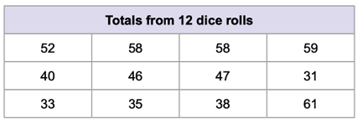
Credit: © The State of Queensland (Department of Education) 2023

- A teacher recorded the height of the students in her class and created the stem-and-leaf plot below.
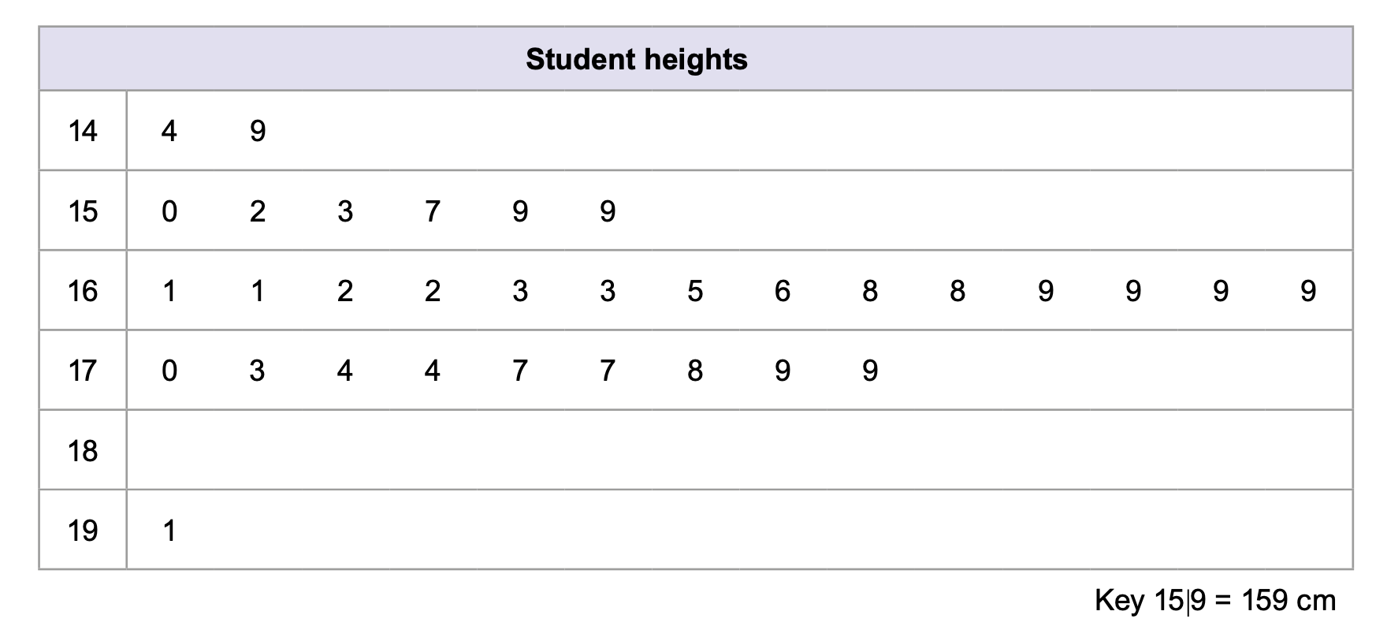
Credit: © The State of Queensland (Department of Education) 2023
- What is the lowest height recorded?
- How many people were measured?
- How many students are below 160 cm?
- What is the mode (most common height)?
- What is the median height of the students?
- How many students are above the median height?
- What is the outlier in this set of data?
- Given this information, approximately how old do you think these students are? Why?
- Would the data change if a different sample was surveyed? How would it change?

