Family maths newsletter ideas:
Primary
Contents
Family maths newsletter ideas: Primary 1
Newsletter series 1: Puzzles and games 2
Puzzles and games: Missing number puzzle 2
Puzzles and games: Snap 2
Puzzles and games: Get Maths Active! board game 3
Newsletter series 2: Maths in the home 4
Maths in the home: Count! 4
Maths in the home: Measure 4
Maths in the home: Cooking 5
Maths in the home: Grocery shopping 5
Newsletter series 3: Maths challenges 6
Maths challenge: Birds on a wire 6
Maths challenge: Chess quest 6
Maths challenge: Adding and subtracting two-digit whole numbers 6
Maths challenge: Order numbers 6
Maths challenge: Which one doesn’t belong? 7
Newsletter series 4: Using our Maths Eyes 8
Using our Maths Eyes: Road signs 8
Using our Maths Eyes: House numbers 8
Using our Maths Eyes: Weather forecast 9
Using our Maths Eyes: Soccer ball shapes 9
Using our Maths Eyes: Supermarket products 9

Newsletter series 1: Puzzles and games

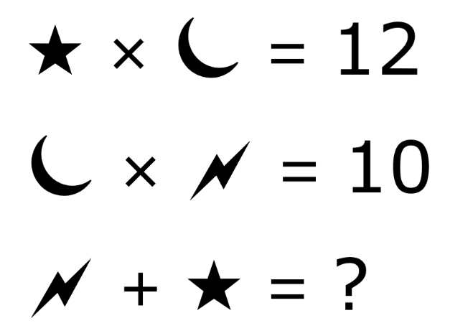
Number puzzle
Puzzles are a fun way to use our maths brains!
Can you solve this puzzle together as a family?
There may be multiple solutions to this puzzle,
can you find one?

Snap
When was the last time you pulled out a pack of cards and had a game of good old-fashioned Snap? There are many variations to Snap, but the commonality between all is that one player turns over a card and if it matches the top card of the pile, then the first person to yell ‘snap!’ and snap the pile with their hand wins
all of the cards.
Try other rule variations, including snapping when the cards total 10, the difference between the
cards is two, or when the cards are a prime number.
Bring out the cards and give Snap another go!

Get Maths Active! board game
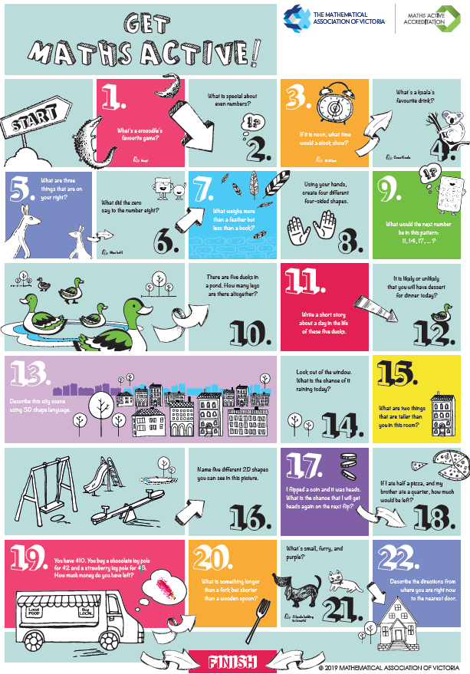
Challenge a family member to this ‘Get Maths Active!’ board game. All you need are some dice and counters. If you don’t have any counters, you could use bottle tops, buttons or toy figurines.

Newsletter series 2: Maths in the home

Maths in the home: Count!
There are heaps of everyday activities that families already do at home that involve real-life maths opportunities. This includes counting anything and everything! Use opportunities to count forwards and backwards or to skip count by 1s, 2s, 5s and 10s.
For example:
- Work out how many plates and pieces of cutlery are needed to set the table.
- Total up the number of sausages needed for a family BBQ.
- Count how many socks there are in the washing pile.
Happy counting!

Maths in the home: Measuring
There are heaps of everyday activities that families already do at home that involve real-life maths opportunities. This includes everyday opportunities for measuring, using ‘formal’ units (such as cups, centimetres or minutes) and ‘informal’ units (for example, how many steps, handfuls, hand claps).
Ask questions such as:
- How far do you think it is from one corner to another? How many steps will that be?
- How many people do you think could sit on our couch?
- Which bag is heavier? Your school bag or your sibling’s bag?
Happy measuring!

Maths in the home: Cooking
Cooking – along with being an enjoyable and creative activity – involves a variety of maths skills. Have your child read the recipe, measure and mix ingredients. Added bonus: your children will also appreciate meals more if they have been actively involved in creating them!

Lois’ vanilla cupcakes (makes 12)
Ingredients  1 cup self-raising flour  ¾ cup caster sugar  ½ cup milk  125 g melted butter  1 teaspoon vanilla extract  2 eggs | Method  Preheat oven to 170ºC.  Place patty pans on a tray.  Mix all ingredients in a bowl with a fork then fill patty pans (approximately two-thirds full).  Bake in the oven for 15-20 minutes.  Best with lemon, orange or passionfruit icing and whipped cream.

Try baking Lois’ cupcakes and send a photo to your teacher!
Happy baking!

Maths in the Home: Grocery shopping
Going to the shops provides plenty of opportunities to ask your children mathematical questions, such
as comparing the value of buying items in smaller amounts to items in bulk.
For example, which product offers best value for money: 250 mL of yoghurt for $1.95 or 1 L of yoghurt
for $7.50?

Newsletter series 3: Maths challenges

Maths challenge: Birds on a wire
Can you and your family solve this maths challenge problem?
Looking up, I saw 9 birds on the overhead wires. I knew that there were 9 without counting them.
How might the birds have been sitting so that I knew there were 9 without counting them?
Good luck!
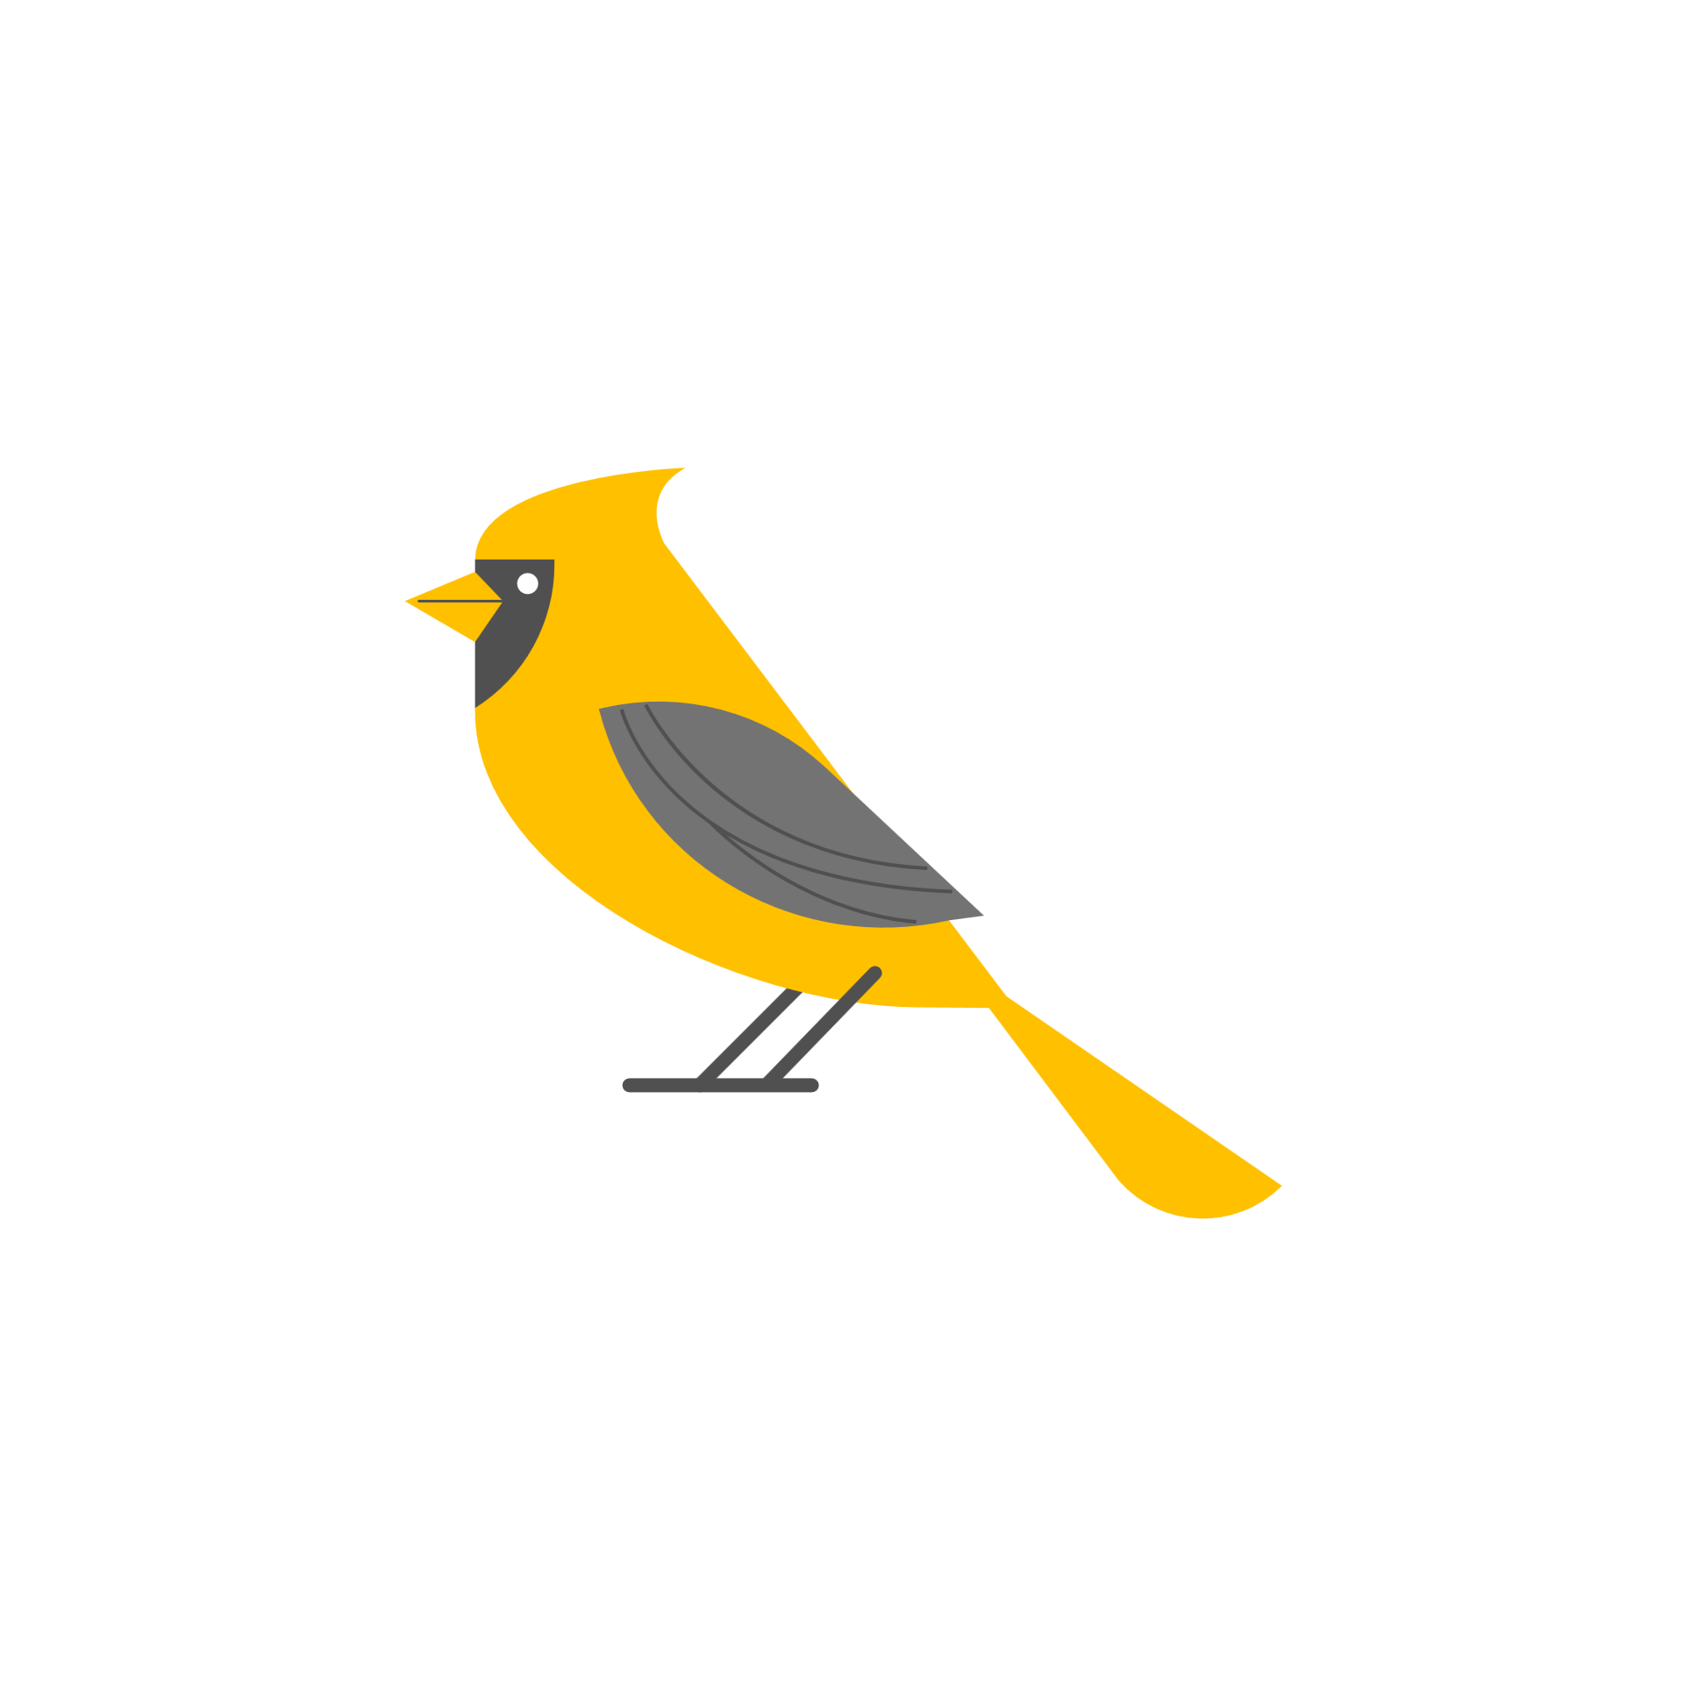

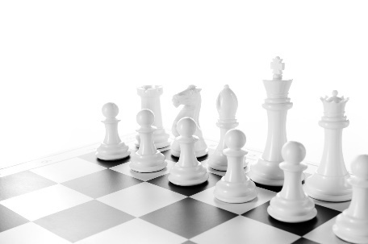
Maths challenge: Chess quest

Find a chessboard or a checkers board – they are the same.
A chessboard has a lot of squares …
But how many squares are there altogether?
Hint: the answer is not 64!

Maths challenge: Adding and subtracting two-digit whole numbers
(http://www.openmiddle.com)
Can you and your family solve this maths challenge problem?
Directions: Use the digits 0 to 9, at most one time each, to make a true statement.


Maths challenge: Order numbers
(https://www.openmiddle.com)
Can you and your family solve this maths challenge problem?
Directions: Using the digits 0 to 9 at most one time each, place a digit in each box to make a two-digit number that has a value between the given numbers.
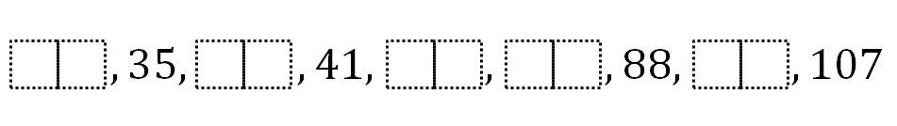

Maths challenge: Which one doesn’t belong?
(Adapted from: http://wodb.ca/numbers.html)
Can you and your family solve this maths challenge problem?
Directions: Choose one of these three images to work out which object, number or equation doesn’t belong and why. Think of at least two different responses.
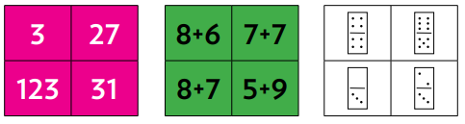

Newsletter series 4: Using our Maths Eyes

Using our Maths Eyes: House numbers
We can use our Maths Eyes whether we’re at home – or out and about! By using our Maths Eyes, we can
see that maths is all around us, wherever we go!
As you walk along the street where you live, what do you notice about the house numbers?
How might you describe the pattern in words?
Can you predict the next number in the sequence?
14
18
20
22
16

Using our Maths Eyes: Weather forecast
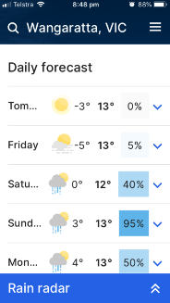
We can use our Maths Eyes whether we’re at home – or out and about!
By using our Maths Eyes, we can see that maths is all around us,
wherever we go!
Check out the weather forecast for the next five days, using
a weather app or the BOM website.
What can you say about the chance of rainfall over the next five days?
How would you describe the overnight temperature in the next five
days, using words like ‘average’ and ‘median’?
Which day is forecast to have the lowest minimum temperature?
Which day is most likely to have rain?

Using our Maths Eyes: Soccer ball shapes
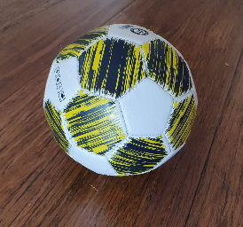
We can use our Maths Eyes whether we’re at home – or out and about! By using our Maths Eyes,
we can see that maths is all around us, wherever we go!
- What shapes does the soccer ball consist of?
- How many pentagons are there on a soccer ball?
- How many hexagons are there on a soccer ball?
- How many hexagons surround each pentagon?
- How many faces does a soccer ball have?
- How many vertices does a soccer ball have?
- How many edges does a soccer ball have?

Using our Maths Eyes: Supermarket Products
We can use our Maths Eyes whether we’re at home – or out and about! By using our Maths Eyes, we can see that maths is all around us, wherever we go!
Have a close look at the nutritional information labels on food products at the supermarket.
- What are its main ingredients?
- How much food does the package contain?
- How much sodium (salt) does the product contain?
- How much fat does the product contain?

