Reasoned rounding game
Instructions:
- Each pair shares one recording sheet.
- Each player will roll the die twice and will then construct a two-digit decimal number (for instance, 0.45). The first player rolls the die twice and decides which order to place their two numbers (for example, if I roll a 4 and 5, I can make 0.45 or 0.54).
- With this number, round it to the nearest tenth. Find the matching circle on the recording sheet and colour in one of the circle halves.
- The second player rolls the die twice and takes their turn in the same way.
- A circle is complete when it has both halves coloured in, and the person who colours in the circle completely scores a point.
- The game is over when all the circles are full, and the points are counted. The highest number of points is the winner.

Recording sheet: https://nrich.maths.org/content/id/10945/Reasoned%20Rounding%20recording%20sheet%20nearest%20tenth%202023.pdf)

I rolled a 3 and a 5! I can make 0.35 or 0.53  I’m going to choose 0.35 |  | I can then colour in one of the halves of the 0.4 circle on my sheet.
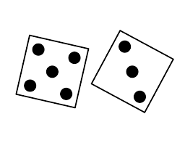 | If I round 0.35 to the nearest tenth,  I round up to 0.4. | 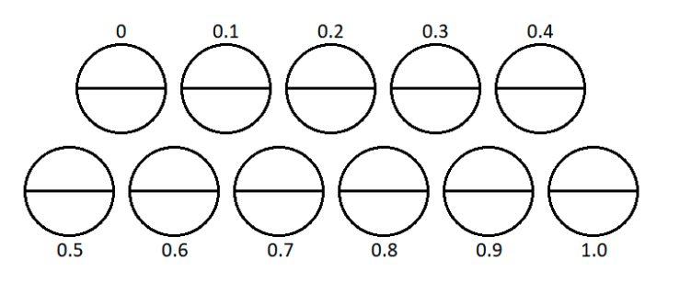
Credit: © University of Cambridge

Credit: © University of Cambridge

