Contents
Family maths event guide 0
Why host a Family Maths Event? 3
Planning a Family Maths Event 3
Step 1: Venue, date, time and volunteers 4
Step 2: Selecting activities 5
Step 3: Program ideas 5
Step 4: Incentives 6
Step 5: Communicating to your community 6
Conclusion 7
References 7
Sample school communication 8
Sample social media post 8
Sample letter 9
Mathematics activity ideas 10
Making nines 11
Snap 12
Flip ten 13
Place value stepping stones 14
Game of Nim 15
Make a dollar 16
River crossing 17
Triangle rule 18
Longer, shorter 19
Game of 31 20
Quarter the cross 21
Trinox 22
Tangrams 23
Pipelayer 24
Pattern snakes 25
20 cm guessing game 28
Coin puzzle 28
Tapatan 30
Domino addition 31
Hare and hounds 32
Snake 34
Higher or lower 35
Mega noughts and crosses 36
Array game 37
Sierpinski tetrahedron 38
Doing your block 39
Spiral race 40
Skunk 41
Target number 42
Square It 43
Frogs and toads 44
Treasure hunt 45
Hundreds chart jigsaw 47
Art gallery problem 48
Bridges of Königsberg 50

Why host a Family Maths Event?
Family engagement in children’s education has a significant impact on student achievement at school. Evidence indicates that community engagement strategies have the greatest impact when linked to student learning.
Family Maths Nights (FME) are a great opportunity to strengthen family engagement in learning and promote
a positive mindset towards maths.
As well as being an opportunity for families to spend quality time together, hosting an FME helps raise the profile of mathematics in the school, and increase awareness among parents and carers about what a contemporary maths classroom looks like, sounds like and feels like.

Planning a Family Maths Event
A successful event can be accomplished with minimal planning. Use the timeframe of activities below to guide the development of an event. A similar timeframe could also be used to plan a STEM event or science fair for families and the school community.

FME planning timeframe
Lead up to event | Activity
3+ months prior | Decide on venue, date, time.
2 months prior | Decide on program and incentives. Arrange for staffing/volunteers.
6 weeks prior | Advertise event to your school community.
4 weeks prior | Decide on activities and start collecting materials.
2 weeks prior | Staff meeting to discuss staff/volunteer roles.
1 week prior | Event location clean up and decorations.  Review RSVPs.
1 day prior | Run off all photocopies and set up station tubs containing all equipment.
Event day | Have fun and trust your planning.

Step 1: Venue, date, time and staffing/volunteers

Venue
Select a suitable venue to cater for your school community. This may be a large hall or gym, or it could be a collection of connected classrooms with an open communal area. If there isn’t sufficient space for the expected number of participants, consider hosting two sessions. If you’re hosting the event in a hall, you might like to arrange chairs in an auditorium seating configuration for the introduction and situate large tables around the edge of the room. When the introductions have finished, ask families to take their chair to a table for the next part of the event.

Date and time
There are several things to consider when selecting a date. It is best to avoid the beginning or end of term, or
the week of school camps, art shows or any other major school activities. In addition, providing 6 weeks’ notice
is optimal. Consider the following common times for hosting an event (90 minutes is a good length of time for
the event).
  - During school hours (for example, 9:00 am to 10:30 am)
  - Straight after school (for example, 3:45 pm to 5:15 pm)
  - In the evening (for example, 5:00 pm to 6:30 pm)
There are positives and limitations to each proposed set of times. Things to consider for your community include parent/carer capacity to attend events during or after school, as well as the workforce demands of teachers.

Staffing/volunteers
Allocate available staff/volunteers to rove around stations to keep spaces organised, gather more equipment
if needed, and provide general troubleshooting advice.

Step 2: Selecting activities
Provide a variety of maths-related games, puzzles and problems for different age groups covering a variety of concepts – see Activity Ideas for suggestions. Approximately 10 to 12 activities set up as stations is sufficient. Encourage families to stick together to solve the tasks. When selecting activities, aim to have hands-on activities.
You may wish to align the activities with concepts that students have been learning in class, to showcase learning that has been happening.
Other ideas for stations include:
- a pile of maths-related picture books
- games such as Uno and Connect 4
- tubs of blocks or LEGO
- tubs of pattern blocks or 3D objects
- computer/iPad games.
Stations incorporating tables, or groups of tables, that can accommodate 6 to 8 people work well. Each table should have the instructions for the task and all equipment needed, including scrap paper and pencils. The instructions could be laminated and stuck to the table. Alternatively, QR codes could be used to link to online instructions.

Preparing the students
You may consider training up the students so they can lead their families around the different activities. This not only saves families time in reading instructions, but also promotes student agency and voice, and encourages students to explain mathematical problems and strategies.

Step 3: Program ideas
Consider how you would like to start the FME. You might like to start with just parents, while students get a head start on activities (under volunteer supervision), or you may want to start with families all together.
Introduction ideas include:
- welcome and purpose of the session
- guest speaker
- short video
- warm-up maths task (either displayed on a screen or printed and placed on seats)
- an overview of the evening.
It is best to keep the introduction short; aim for a maximum of 15 minutes.

Step 4: Incentives
Consider offering incentives for participation. This may include the following ideas:
- prizes, stickers or certificates
- a Family Maths Event Passport: students get a stamp/signature upon completing various tasks
- house points (or similar) for solving specific problem-solving tasks
- a maths lucky dip
- food treats as prizes for completing tasks, such as hot chocolate and biscuit, sausage sizzle, icy pole
or ice cream
- maths-themed fancy dress (with a prize for best costume); for example, students could dress as their favourite number, a calculator, a geometric shape or as their favourite mathematician
- a maths party bag to take home, for example, containing event tasks, dice and a pack of cards.
In addition, guest speakers or participants may provide excitement. This may be a local member of parliament,
a newspaper reporter, a community business owner, or a representative from the Department of Education or
a state-based mathematics association (such as the Mathematical Association of Victoria).

Step 5: Communicating to your community
Getting the word out about your school’s FME in a timely manner is a crucial step in the success of the event. Provide parents/carers with approximately six weeks’ notice.
You may wish to advertise the event in the school newsletter, via social media posts, or with an invitation letter. Having students write an invitation to their family is a great way to build excitement around the event. Garner students’ enthusiasm for the event by discussing it during assemblies and in class.
Send out a reminder to participants a few days before.

RSVP
Including an RSVP is useful for getting an indication of how many families will be attending. Families could
RSVP with:
- an email to the classroom teacher/organiser
- a return slip on an invitation
- an event posted in school management software (for example, Compass)
- an event booking ticketing system (for example, Eventbrite).

Conclusion
Family maths events are a fabulous way to engage parents and carers in learning while supporting communities
to come together. Have fun and enjoy connecting with your school community!

References
Bethelsen, D., & Walker, S. (2008). Parents’ involvement in their children’s education, Family Matters, 79. Australian Institute of Family Studies.
Emerson, L., Fear. J., Fox, S., & Sanders, E. (2012). Parental engagement in learning and schooling: Lessons
from research. A report by the Australian Research Alliance for Children and Youth (ARACY). Family-School
and Community Partnerships Bureau: Canberra.

Sample school communication

Sample social media post

Family Maths Event
Date:
Time:
Location:

Get ready for a fun-filled evening of numbers, games and problem-solving at our Family Maths Event!
Bring the whole family and join us for this interactive maths adventure and quality family time together.
We encourage children to come dressed in their favourite maths-themed outfit. Whether it’s a human calculator, a geometric shape, or a famous mathematician, let their imaginations run wild!
Please RSVP via the link to ensure we have enough maths-tastic goodies for everyone: [RSVP link]
It’s going to be a fantastic family maths experience. We can’t wait to see you on [insert date]!

#familymathsnight #mathsmania #familytime #familyengagement

Sample letter

Dear families,

To celebrate National Literacy and Numeracy Week this year, we will be hosting a Numeracy open morning. This is an exciting opportunity for families to learn and have fun together exploring puzzles, problems and games. It is also an opportunity to promote a positive maths mindset and for parents and carers to find out what maths looks like in their child’s classroom.
The morning will commence with a whole school assembly featuring a special guest presenter. Immediately following the assembly, parents and carers are invited to visit their child’s classrooms to engage in classroom maths activities and view mathematics artworks on display. To conclude the morning, a giant picnic will be held on the oval.

Date:
Time:
Location:

Please RSVP to ensure we have enough maths-tastic puzzles for everyone. RSVP via Eventbrite <insert link> or use the QR code.
I would like to thank the efforts of the Numeracy team putting together this fabulous event for parents/carers. We look forward to seeing you at our Family Maths morning!

Kind regards,

[insert name]
sample
Principal

Mathematics activity ideas
Years F to 2 | Years 3 to 6 | Years 7 to 10
Snap | Making nines | Making nines
Flip ten | Place value stepping stones | Game of Nim
Make a dollar | Game of Nim | Trinox
Tangrams | Make a dollar | River crossing
Game of Nim | Tangrams | Quarter the cross
Place value stepping stones | River crossing | Pipelayer
Triangle rule | Triangle rule | Game of 31
Snake | Tapatan | Hare and hounds
Longer, shorter | Domino addition | Array game
Pattern snakes | Spiral race | Skunk
20 cm guessing game | Array game | Greedy pig
Coin puzzle | Sierpinski tetrahedron | Target number
Higher or lower | Mega noughts and crosses | Square it
Target number | Doing your block | Frogs and toads
Hundreds chart jigsaw | Skunk | Treasure hunt
 | Target number | Art gallery problem
 | Square it | Bridges of Königsberg
 | Treasure hunt
 | Art gallery problem
 | Bridges of Königsberg

Making nines
Materials: One set of cards 1 to 9

Instructions:
Arrange the cards to make the totals shown.
How many solutions can you find for each?

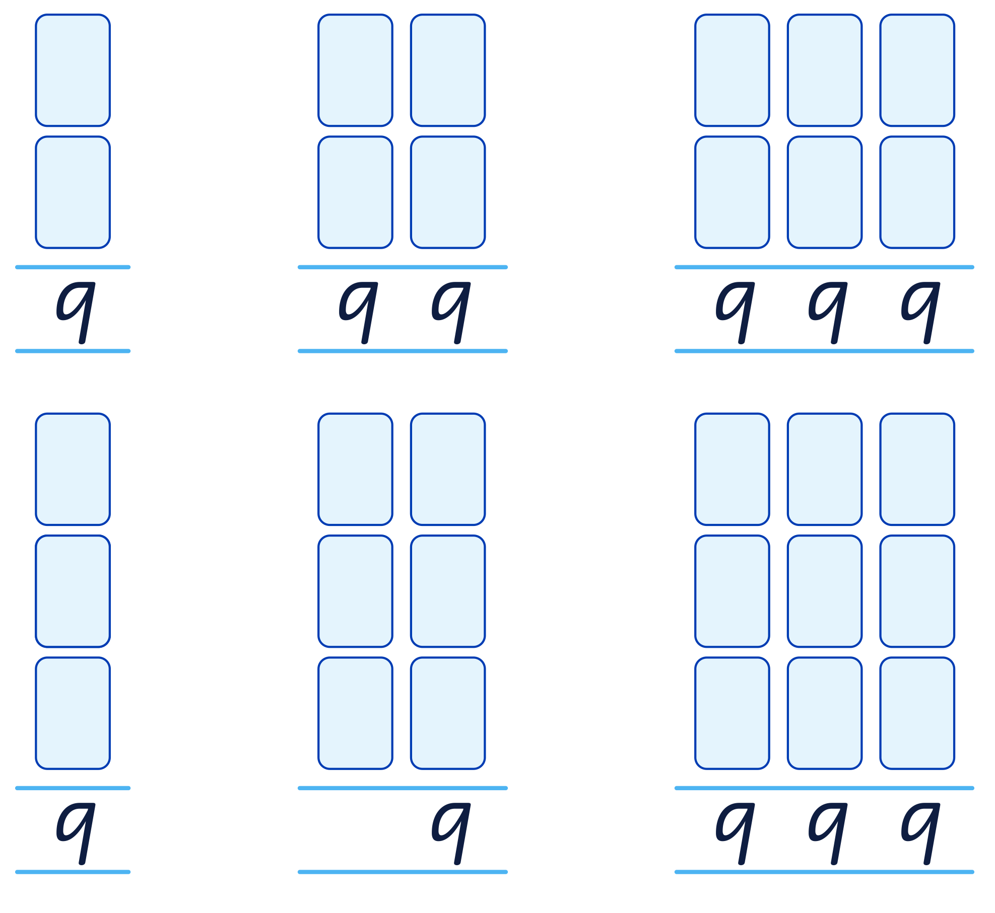

Image: MAV Family Maths Nights 2015

Snap
Materials: One deck of cards
Players: 2 to 4

Instructions:
Play the traditional two pile game of Snap, however, try these alternatives:
- Snap when the difference of the cards is 1.
- Snap when the cards total 9.
- Snap when the cards demonstrate a multiple of each other (2 and 6, or 3 and 9).

Snap: Difference of 1

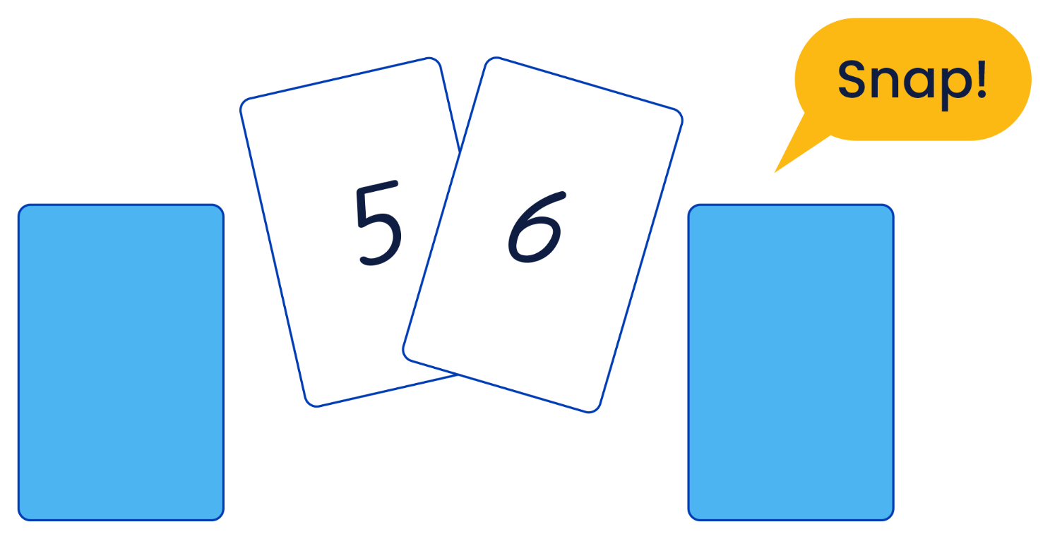

Image: MAV Family Maths Nights 2015

Flip ten
Materials: One deck of cards (picture cards removed, ace equals 1)

Instructions:
Arrange playing cards face down on the table in a grid formation.
Each player takes it in turns to flip two cards over.
To form a match, the numbers on the cards must add up to 10.

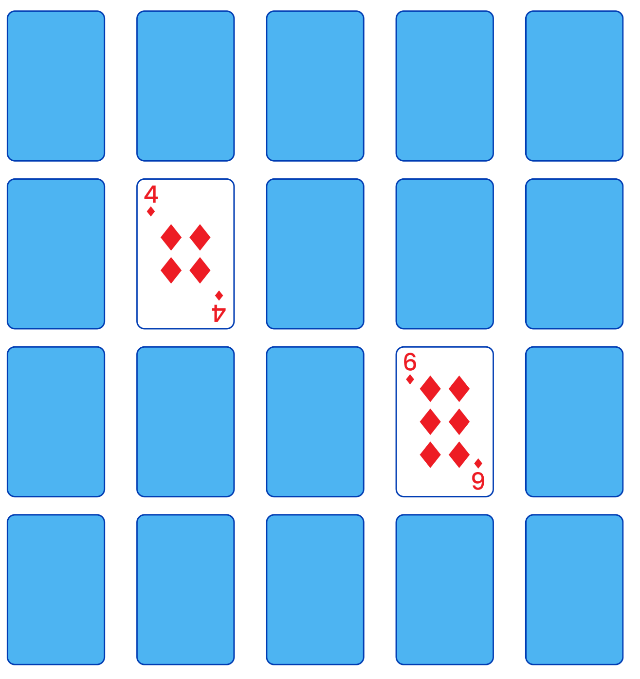
Image: MAV Family Maths Nights 2015

Place value stepping stones
Materials: Two x 10-sided dice per player, Place value stepping stones path per player, pencil
Players: 2 to 4

Instructions:
The first player rolls their two dice and creates a two-digit number. The player writes the number they have created on one of the stepping stones. While selecting a place to write the number, keep in mind the numbers need to be placed in order along the path. 0 is at one end of the path and 100 at the other end. A player will
lose a turn if their two-digit number cannot be placed on the path. Continue to take turns until one player has
a number on every stepping stone along their path and all the numbers are in order.

Place value stepping stones

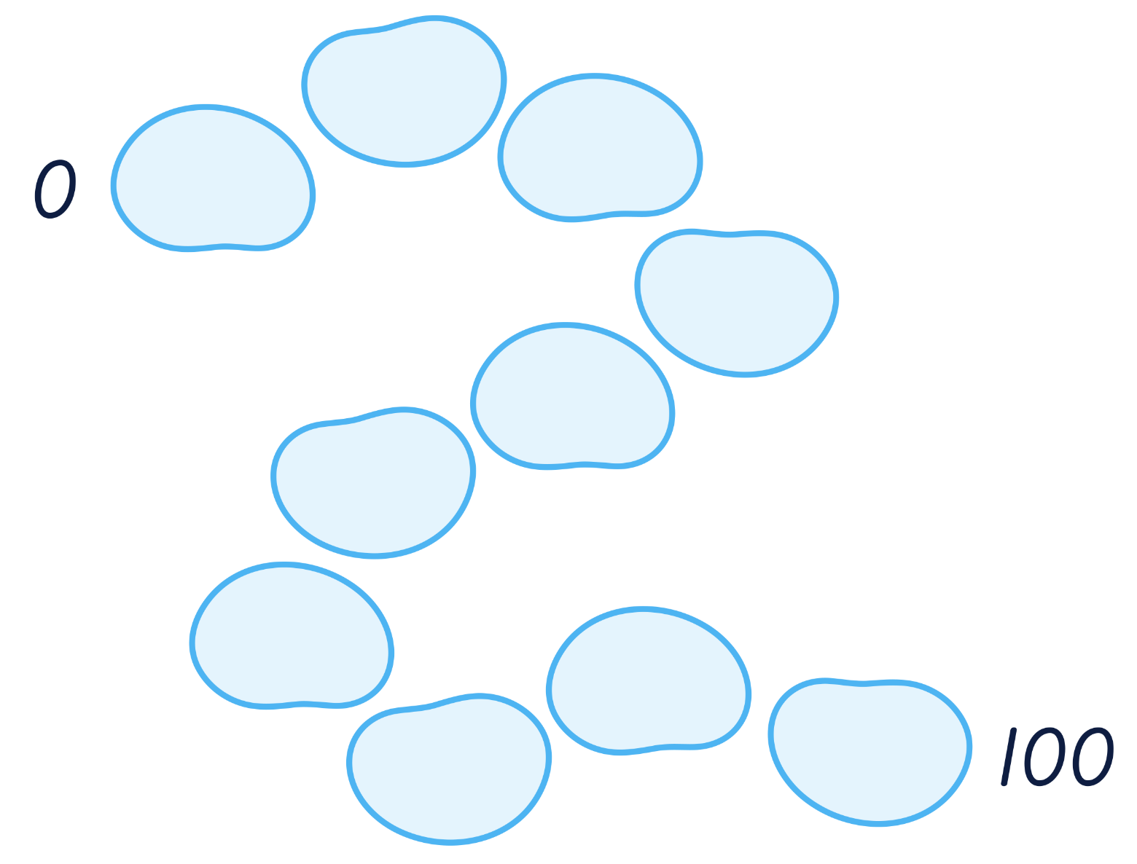

Game of Nim
Materials: 12 counters
Players: 2

Instructions:
Players take it in turns to remove one or two counters.
The winner of the game is the player who removes the last counter.
Play 10 times.



Did you notice a pattern?
Could you describe the way to win?
What if you started with 15 counters?
What about 10 counters?

Adapted from NRICH

Make a dollar
Materials: One 6-sided die, 20 x 5c coins and 20 x 10c coins
Players: 2 to 4

Instructions:
Place all the coins in a dish or in a pile in the middle of the players. Players take turns to roll the dice and then
take as many coins as is shown on the dice.
For example, if you roll a 4 you can take four coins from the collection. It is up to the player whether they take
5c or 10c coins.
The amounts are added up as you go, and the goal is to be the player who gets as close to a dollar as possible without going over one dollar.

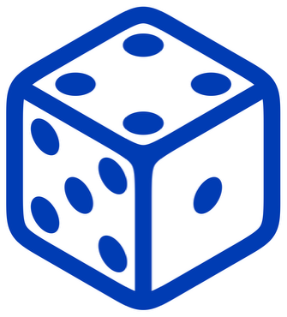


Variation:
Each play only has six rolls of the die each.
Use two dice per roll.

Adapted from The Best of Family Maths, Family Maths Project Australia

River crossing

Instructions:
A man has to get a fox, a chicken and a sack of corn across a river.
He has a rowboat, and it can only carry him and one other thing.
If the fox and the chicken are left together, the fox will eat the chicken.
If the chicken and the corn are left together, the chicken will eat the corn.
How does the man do it?
Record your moves.

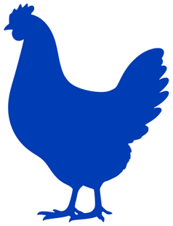



Hint: Use objects such as counters, blocks or models to represent the characters.

Triangle rule
Materials: Paper, pencil and ruler
Players: 2

Instructions:
Players take turns ruling a straight line connecting any two points on the circle.
The first player to form a triangle loses.



Variation:
Players use two different colours and the first player to form a triangle in their colour loses.

Longer, shorter
Materials: One die
Players: 2 to 4

Instructions:
The youngest player goes first.
Each player takes it in turn to roll the die and follow the instructions.

Die | Find something that is:
1, 2 | shorter than your hand
3, 4 | longer than your hand
5, 6 | the same size as your hand



Game of 31
Materials: One deck of cards, with only ace (1) to 6 of each suit
Players: 2
Aim: To make the total exactly 31. If you go over, you lose. One point for each win.

Instructions:
- Use ace (1) to 6 of all suits from a deck of cards.
- Set them out in an array as shown below.
- Take turns at turning over one card. You add the total of each turned over card as you go.
Say it out loud.

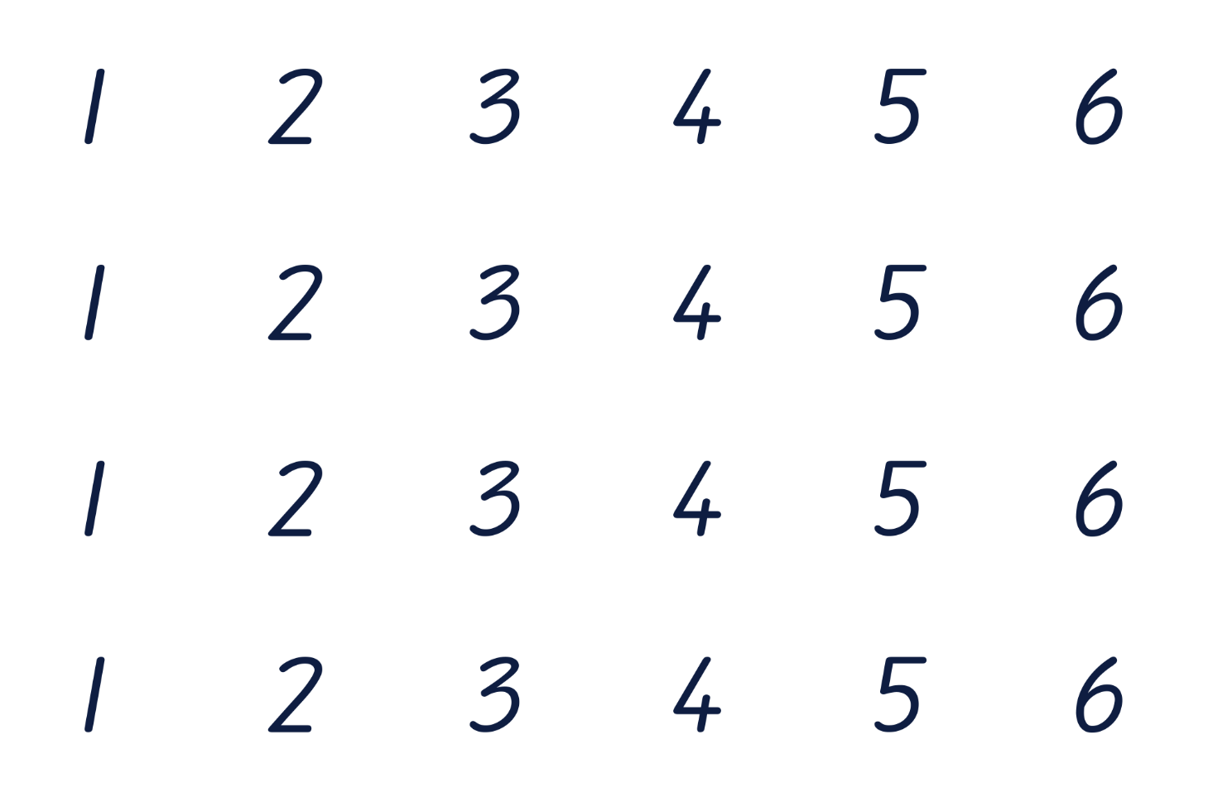

Image: MAV 31 Games for Maths Games Day, 2023

Quarter the cross

Instructions:
Colour in one-quarter of the cross. You must be sure it’s exactly a quarter.
How many different ways can you do it?

Quarter the cross blog

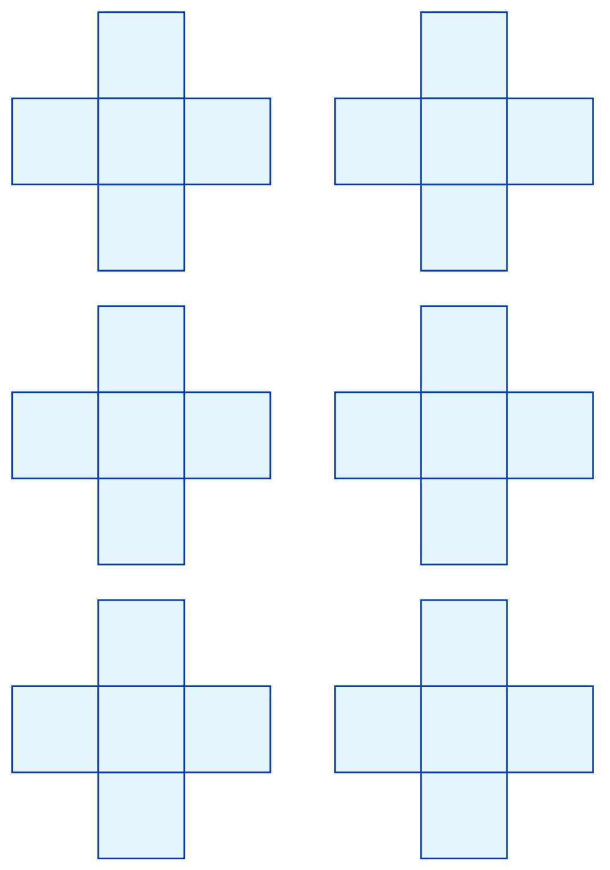

Trinox
Materials: Two sets of different coloured counters (13 counters per set)
Players: 2
Aim: To obtain three cubes in a line.

Instructions:
Players take turns to place a counter of their colour on the board, to get three in a line, horizontally, vertically
or diagonally.
Counters may be placed on top of other cubes, up to three cubes high only.



Image: MAV 31 Games for Maths Games Day, 2023

Tangrams
Materials: Scissors, tangram puzzle pieces
Players: 1 or play as a pair

Instructions:
Cut out one tangram puzzle and use all of the pieces to create each of the animal images.
Each picture uses all of the pieces of the tangram puzzle. No extra pieces are used to create each image.

Tangram puzzle pieces
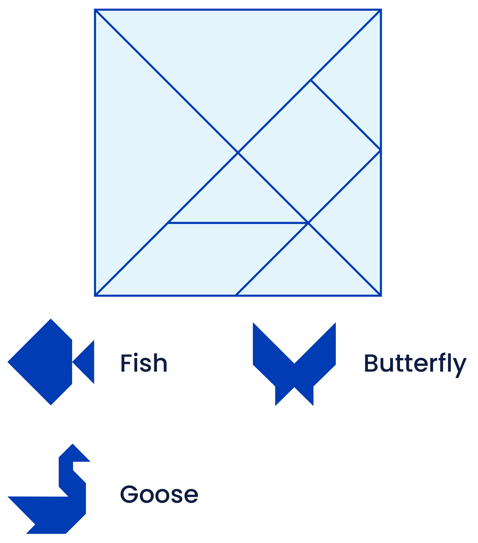
Images: MAV Family Maths Nights 2015

Pipelayer
Materials: Pipelayer grid, pen
Players: 2
Aim: To make a continuous connection from one side of the board to the other.

Instructions:
Pipelayer is a game played with two grids of dots that are slightly offset from one another. The grids contain white and black dots. This example has 6 x 7 and 7 x 6 grids of dots. Each player has one longer dimension.
Players each choose a different colour dot. A player may only connect their own coloured dots. Dots may be connected with an adjacent dot either horizontally or vertically. Those connecting black dots move from top to bottom. Those connecting white dots need to connect from left to right.
Players take it in turns connecting two dots. No lines may cross each other.

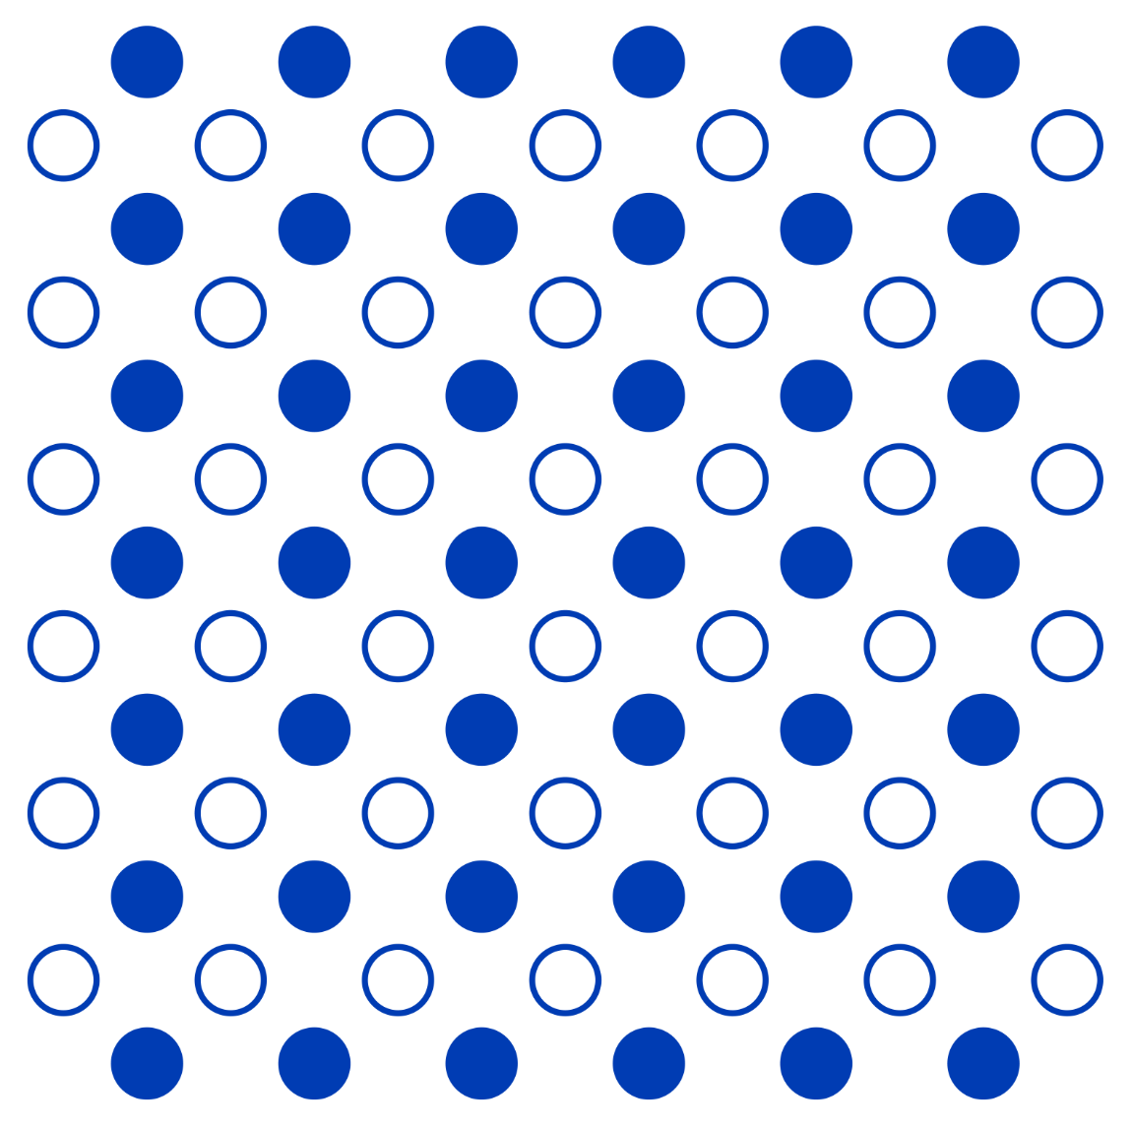

Pattern snakes
Materials: Snake templates (blank and prepared), leaf templates, coloured shape cut outs, glue sticks,
scissors for cutting paper (suitable for adults and students), coloured paper (optional but handy)
Players: Best for a small number of children and at least one adult for cutting out and directing the snakes

Instructions (preparation):
- Gather materials.
- Prepare a set of blank snakes ready for players (template provided). The templates can be enlarged
to suit your learners.
- Prepare multiple sets of coloured paper shapes, either using the shapes provided or using your own coloured paper. The shapes need to be small enough to fit inside the snake outline and form its pattern.
- Prepare one or two blank snakes with shapes already glued down in a pattern, as an example for
the group.
- Prepare some green paper so the groups can cut out some leaves (or use the templates provided).

Instructions (for play):
The aim of the game is first to recognise patterns, predict patterns, then make patterns, using the pattern snakes as a simple template.
- Cut out some leaves and make a bundle large enough to hide a snake (use the templates provided).
- Using an example pattern snake provided, hide one snake under the leaves and slowly reveal it coming out from under the leaves, showing its beautiful pattern.
- Repeat and ask children to predict which shape/colour will come next. Ask them to show the repeating part of the pattern.
- Cut out a set of blank snakes and invite students to make their own pattern snakes using the glue and the coloured shapes provided. Students then play the snake emerging game, asking their friends/family to guess their patterns.
- Students can take their snakes home at the end of the Family Maths Event.



Pattern snakes (cont'd)

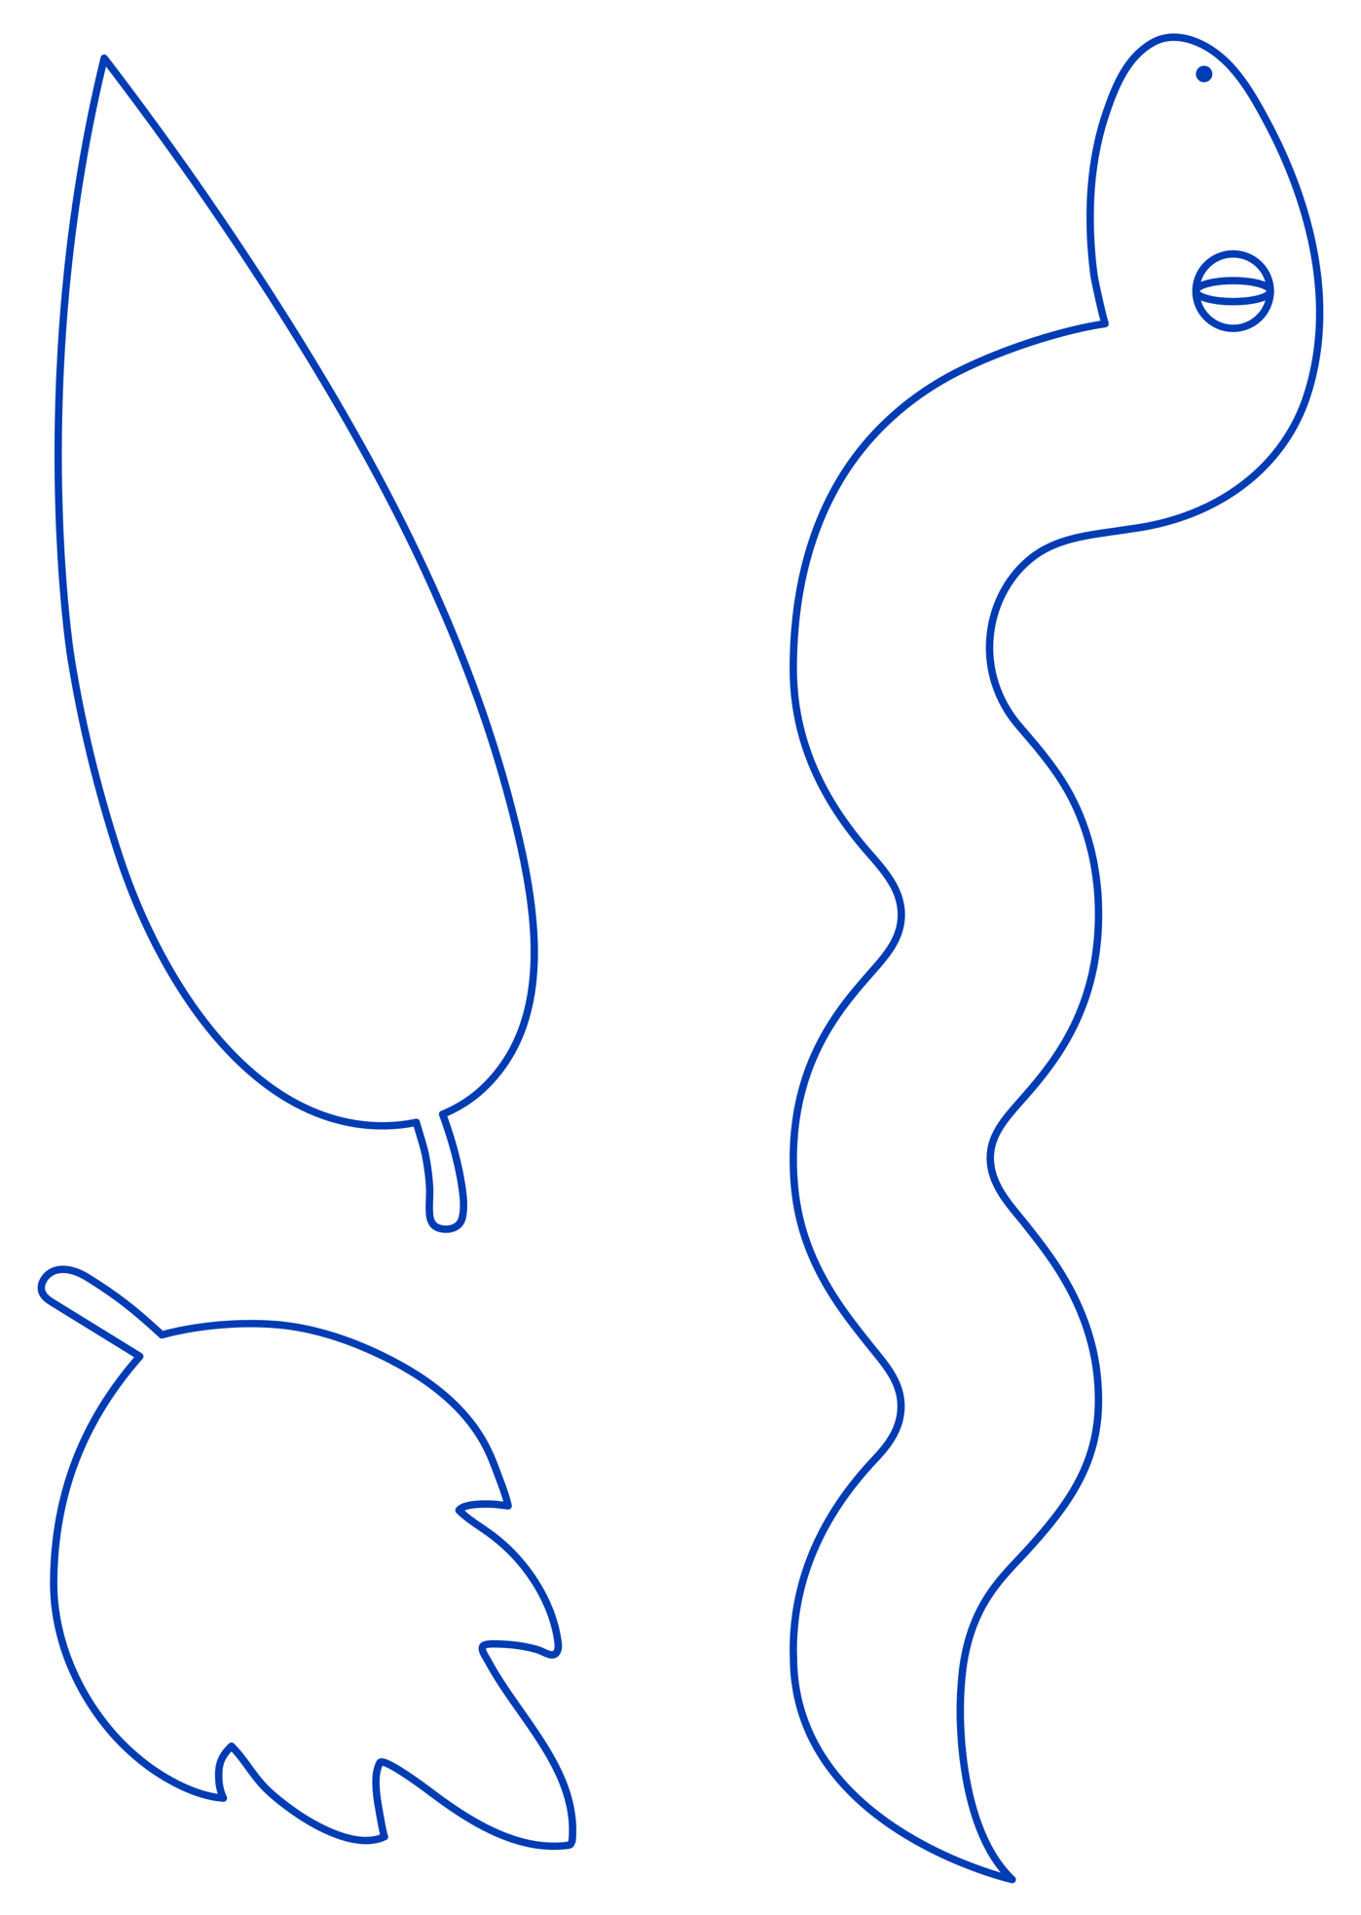

Pattern snakes (cont'd)



20 cm guessing game
Materials: Tub full of different-sized objects (toys, household objects or classroom objects –
an assortment of sizes and shapes is best), rulers, measuring sticks and/or measuring tape
Players: 2 to 6

Instructions:
An adult in the group states a measurement; start with 20 cm. The children pick items from the tub that they
think would be close to measuring 20 cm long. Then each object is measured, and the winner is the one that’s closest to 20 cm.
Encourage discussions of ‘Which way is the length?’, ‘What if you measure it across this way?’ or similar. These
are all good conversations to have, as there is no right answer. Also ask ‘Whose object was shorter than 20 cm?’, ‘Whose was longer?’, to encourage use of measuring and comparing words.
After the 20 cm round, the adult can choose different lengths to state, and children can choose different objects from the tub.
To extend the game, adults can state much longer lengths, then challenge children to line up multiple objects
to make their guess, before checking with a measuring stick or tape.




Coin puzzle
Materials: Assortment of coins (as shown below) or print and laminate image below
Players: 1 or 2
Aim: This money needs to be shared equally between two people.

Instructions:
Can you find three ways to share the money?
Is there a way to share the money equally between three people?

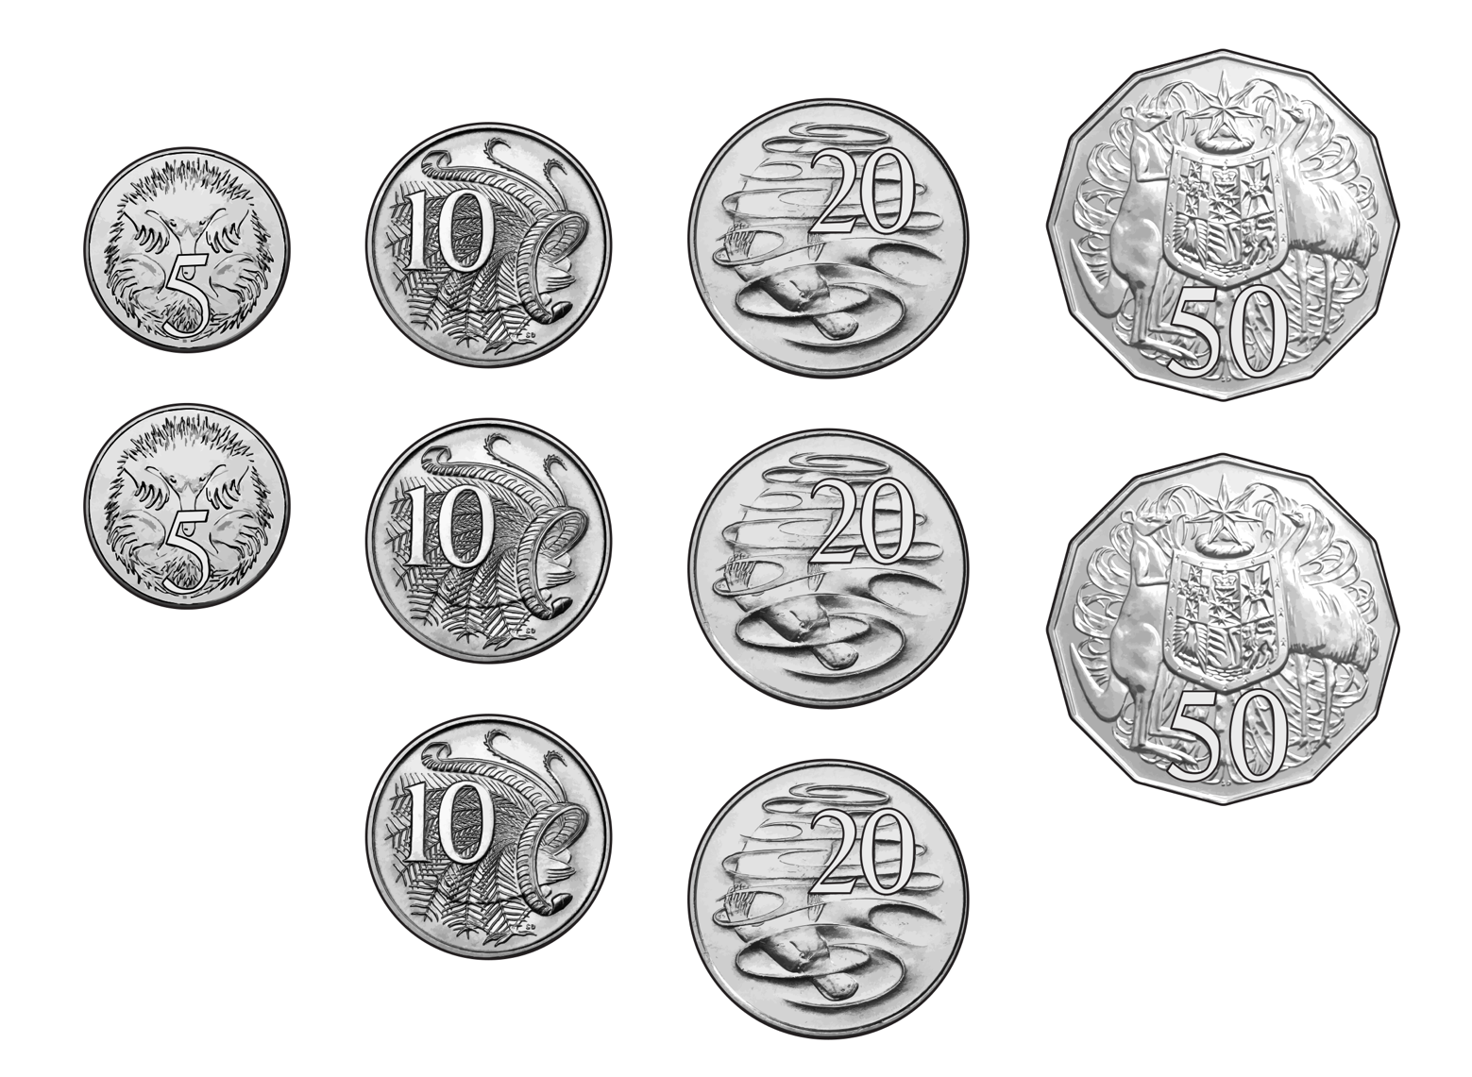

Tapatan
Materials: Two sets of three counters (or buttons or coloured stones), each set a different colour
Players: 2
Aim: To get three of your counters in a line.

Instructions:
Players take a set of counters each and decide who goes first. They then take turns placing a counter on a dot
on the game board. Only one counter can go on a dot. Once all the counters are placed, players then take turns, sliding their pieces along a line to an empty dot. The winner is the person who gets three of their counters in
a straight line.

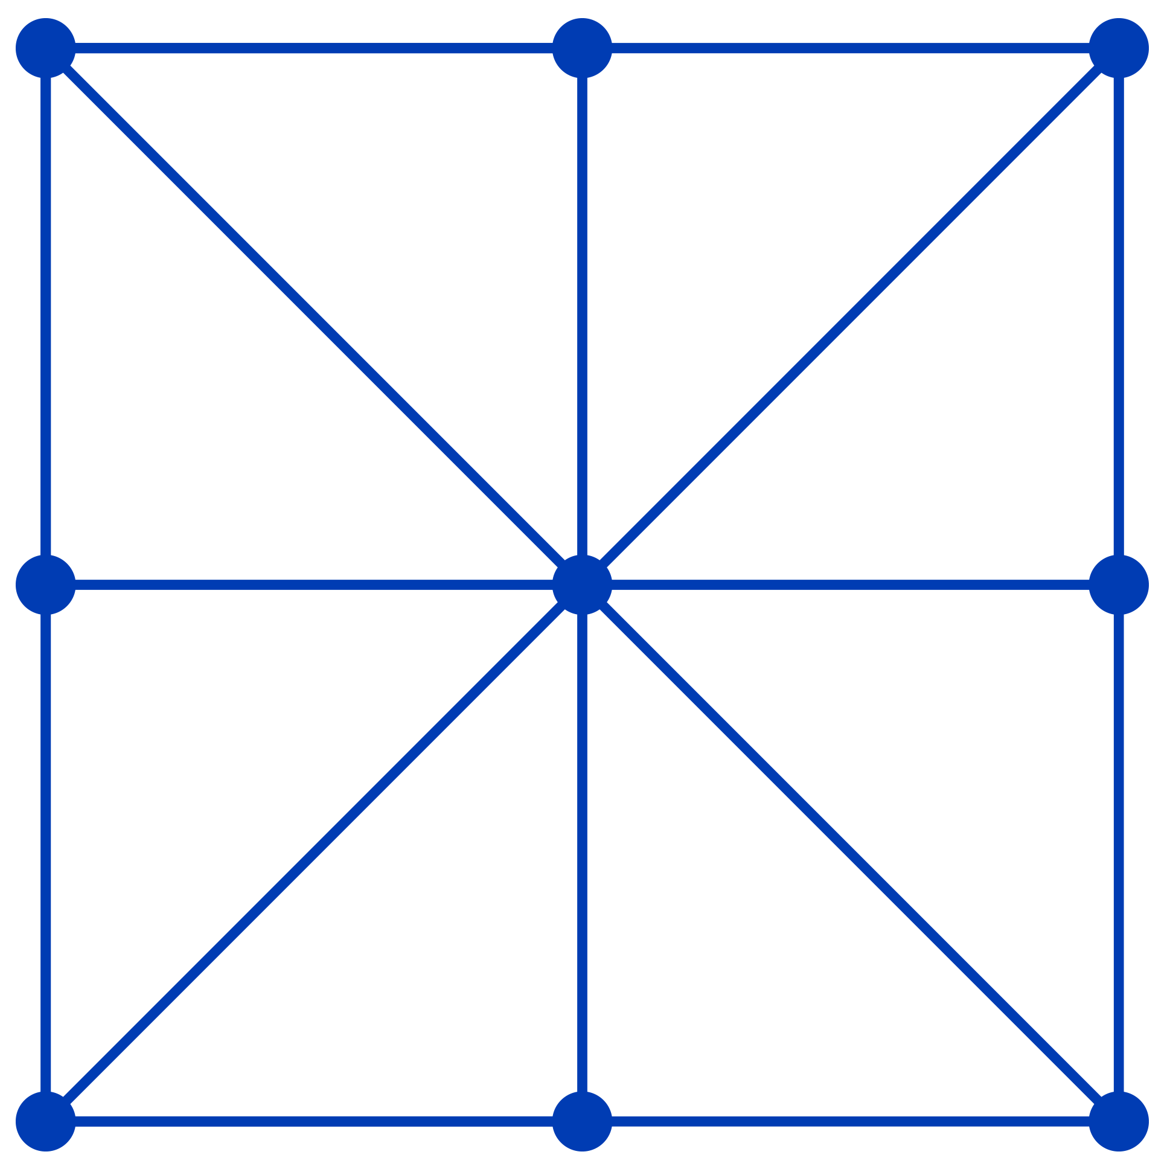

Tapatan is a game from the Philippines; there are many variations of this game all over the world.

Domino addition
Materials: Set of dominoes, paper, markers

You can use dominoes to make addition problems, like this one:
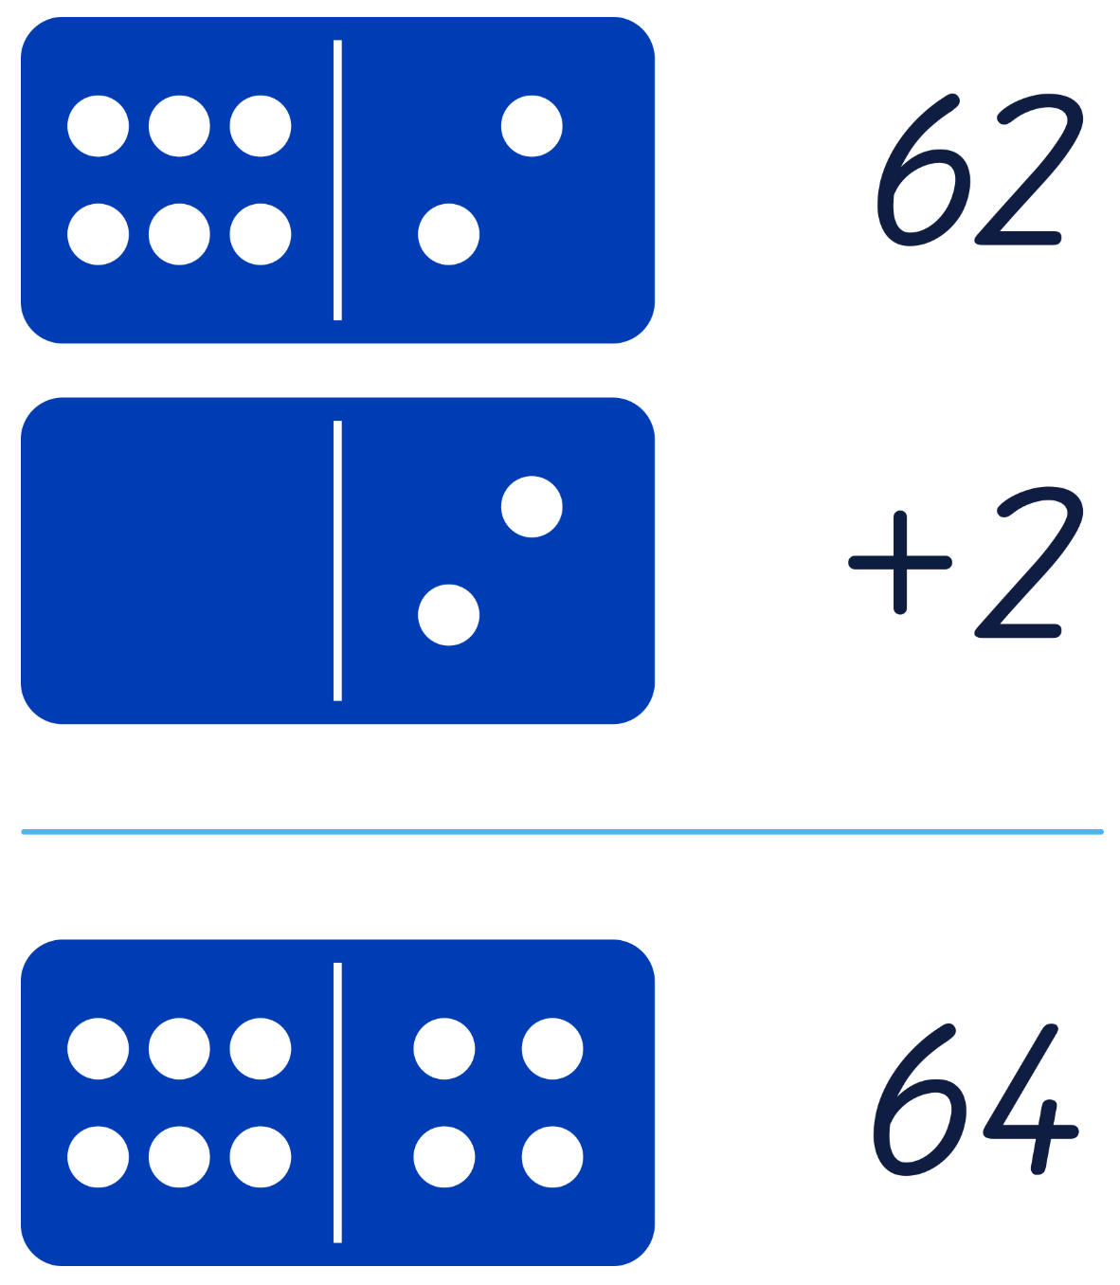

Can you make some more addition problems?
Can you make subtraction problems?
Are there any problems that you made that don’t have a ‘domino’ answer?

Hare and hounds
Materials: two sets of counters – one counter for the hare, and three of another colour
for the hounds (buttons or coloured stones also work well)
Players: 2
Aim: For the hare to escape or for the hounds to catch it!

Instructions:
Players decide which animal they would like to play. The hounds are placed on the three corners at one end
of the board, like so:

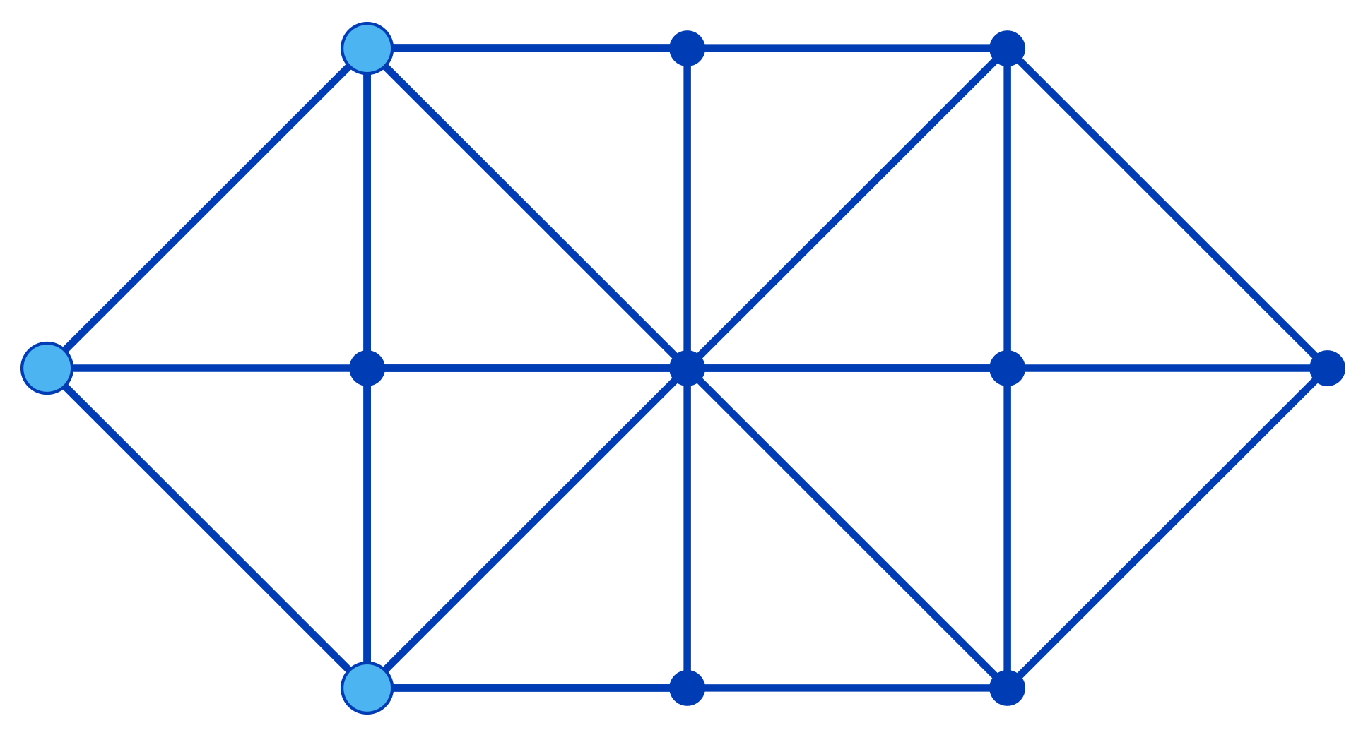

The hare player can place their counter on whichever dot they like. Players decide who goes first, and then take turns moving. Pieces can only slide along the lines to empty dots, one space per turn.
Hounds can move forward, diagonally forward or sideways. They can never move backwards, that is, never back towards their starting side. The hound player can only move one hound each turn.
The hare can move in any direction and moves one space per turn.
If the hounds surround the hare so it can’t move, the hound player wins. If the hare makes it past all three hounds and to the other side of the board, the hare wins.

Hare and hounds is a variation of a game that’s been played for hundreds of years.

Hare and hounds (cont'd)

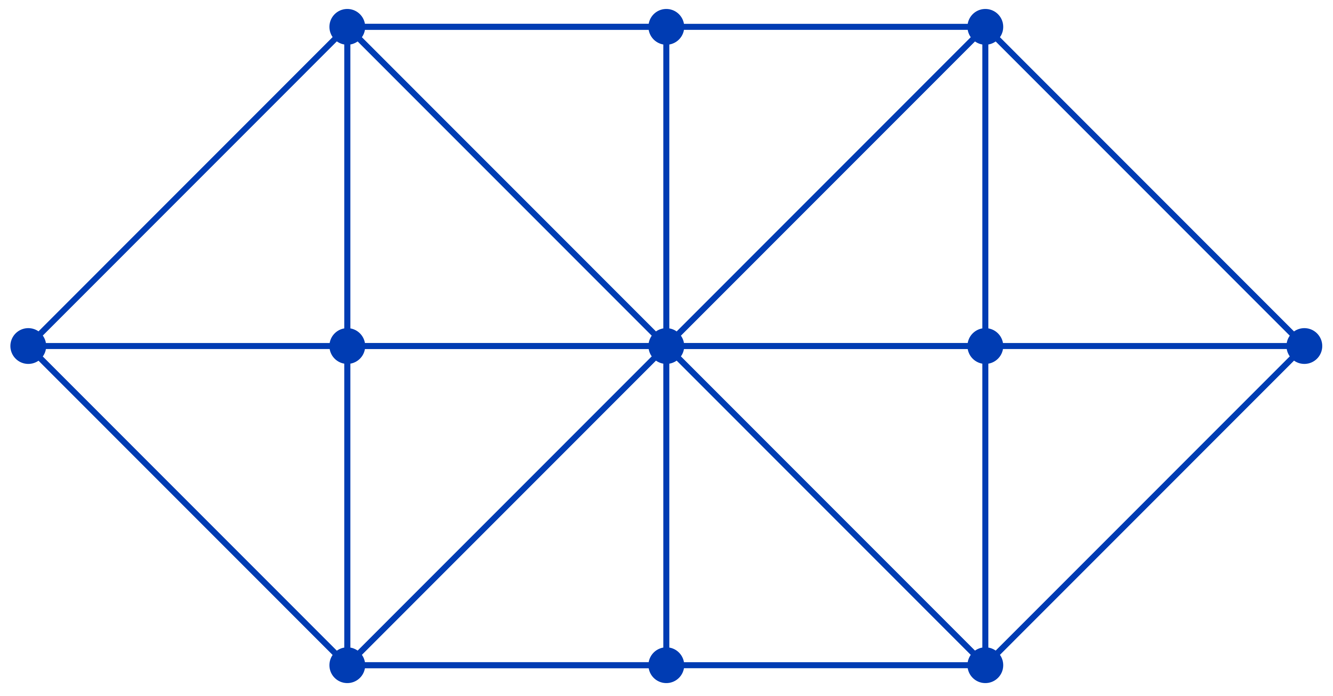

Snake
Materials: Two dice, two pieces of paper, markers
Players: 2

Instructions:
- Draw a snake with the numbers 2 to 12 along its body, from head to tail.
- Each player needs their own snake game board.
- Players take turns to roll two 6-sided dice. They add the numbers together and cross out the total
(for example, if 5 and 1 is rolled, cross out the 6).
- If your number has already been crossed out, you miss a turn.
- Discuss what you need (for example, you have an 11 left, so need to roll a 5 and 6).
- The first player to cross out all numbers on their game board wins.

Variations:
- Use two 10-sided dice and write the numbers 2 to 20 on the snake.
- Use two 10-sided dice and subtract the numbers instead of adding.
- Write 0 to 9 on the snake (if you have dice with the numbers 0 to 9).

- Draw different game boards, such as roads, trains, snails.

Higher or lower
Materials: None required, but a number chart could be used to cross off the numbers
that are guessed (or cover them with a counter)
Players: 2 or more

Instructions:
- Decide on a number range, for example, 1 to 100 or 1 to 1000.
- Player 1 thinks of a number and secretly writes it down.
- Player 2 takes turns guessing the number.
- Player 1 responds with ‘higher’ or ‘lower’.
- The guessing continues until the secret number is revealed.
- If there are more than two players, additional players take turns having a guess after Player 2. Each player should listen carefully to the guesses to keep track!

1 | 2 | 3 | 4 | 5 | 6 | 7 | 8 | 9 | 10
11 | 12 | 13 | 14 | 15 | 16 | 17 | 18 | 19 | 20
21 | 22 | 23 | 24 | 25 | 26 | 27 | 28 | 29 | 30
31 | 32 | 33 | 34 | 35 | 36 | 37 | 38 | 39 | 40
41 | 42 | 43 | 44 | 45 | 46 | 47 | 48 | 49 | 50
51 | 52 | 53 | 54 | 55 | 56 | 57 | 58 | 59 | 60
61 | 62 | 63 | 64 | 65 | 66 | 67 | 68 | 69 | 70
71 | 72 | 73 | 74 | 75 | 76 | 77 | 78 | 79 | 80
81 | 82 | 83 | 84 | 85 | 86 | 87 | 88 | 89 | 90
91 | 92 | 93 | 94 | 95 | 96 | 97 | 98 | 99 | 100

Mega noughts and crosses
Materials: Whiteboards or pieces of paper, markers
Players: 2

Instructions:
- Draw a 5 x 5 grid on a piece of paper or a whiteboard.
- Decide who is X and who is O.
- Players take it in turns to place either an X or an O in a square until the board is filled.
- Go through the grid to find lines of 3, 4 or 5.
5 in a row = 5 points
4 in a row = 4 points
3 in a row = 3 points

Add up the total amount of points you get from the grid to see who wins. Discuss what winning strategies
were used!

Array game
Materials: Two dice, grid paper, different colour marker for each player
Players: 2 to 3

Instructions:
- Player 1 rolls the two dice and draws a rectangle that represents the array of the two numbers rolled
(for example, if a 2 and a 5 has been rolled, they'd claim a rectangle that's 2 x 5 squares, or 5 x 2 squares).
- Player 2 rolls the dice and does the same.
- Players keep taking turns to fill up the board.
- Skip a turn if you cannot draw a square/rectangle.
- At the end, count how many squares were filled in by each player. They player who filled in the biggest
area wins.
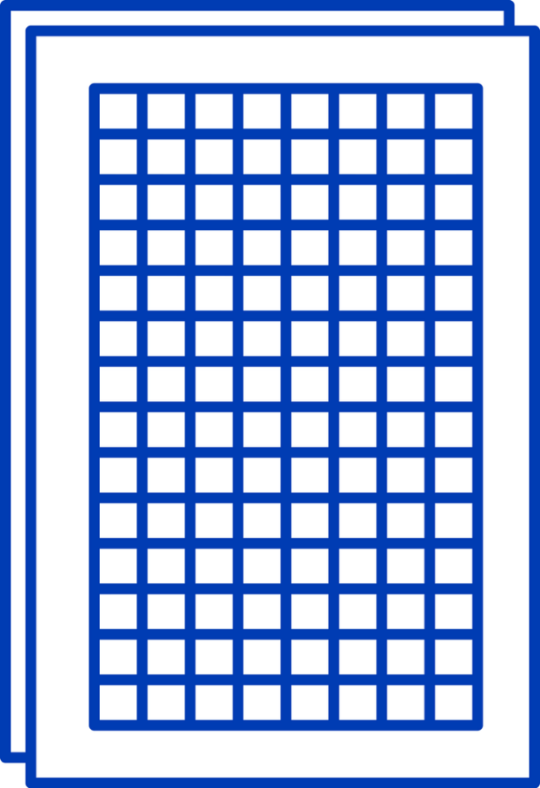
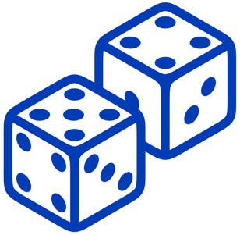


Sierpinski tetrahedron
Materials: Tetrahedron template, paper, pencils or markers, rulers, glue, scissors, adhesive tape

Instructions:
Build a tetrahedron from a net and decorate. Then join four tetrahedrons together to make a Sierpinski tetrahedron – something mathematicians call a fractal, a never-ending pattern of self-similar shapes that
repeats itself.

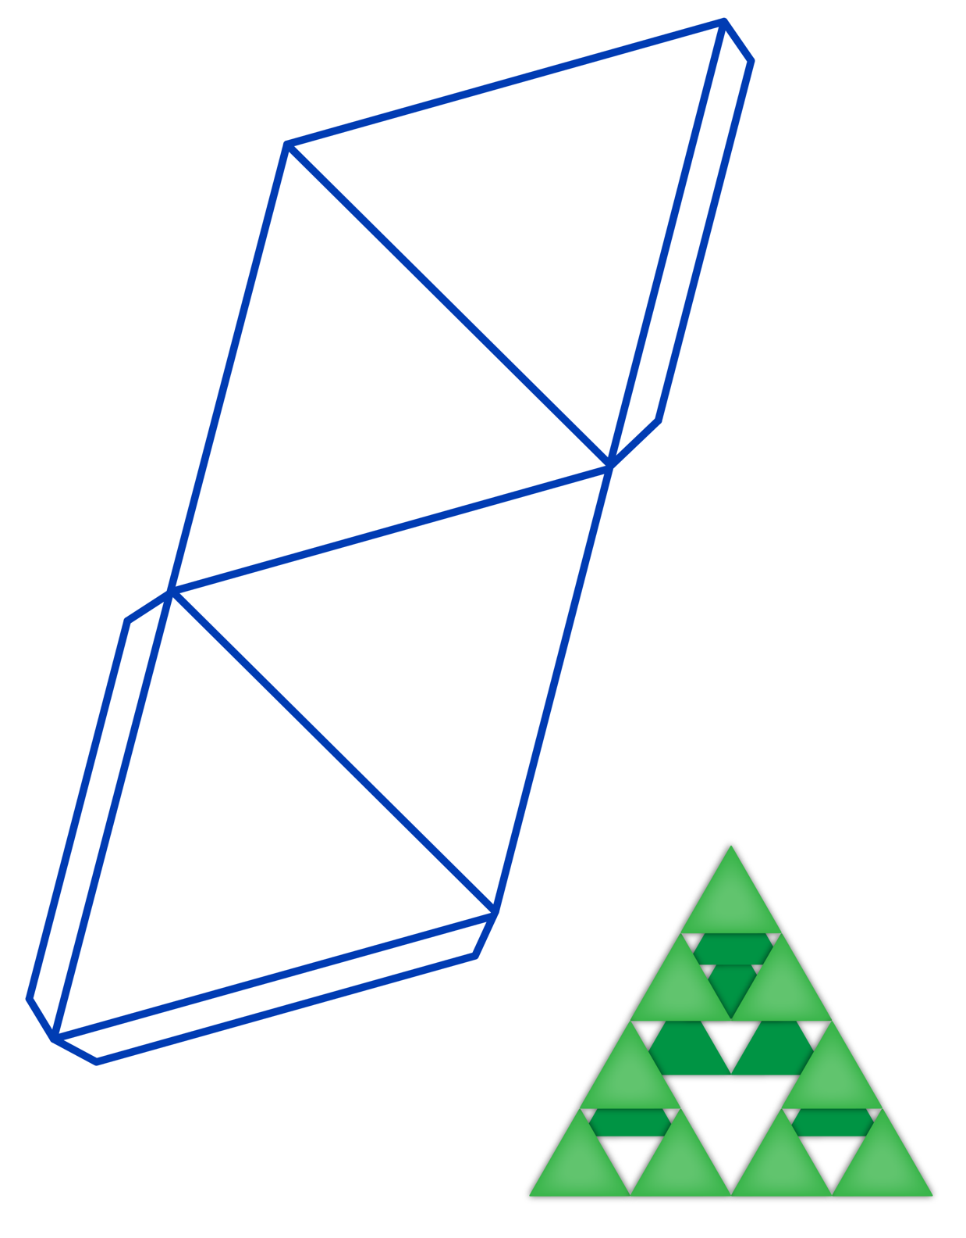

Doing your block
Materials: Multilink cubes (white, pink, orange, purple and black)
Players: this would work best in pairs, or with an adult supporting 1 or 2 children

Instructions:
Assume that each 'layer' of this cube is made up of smaller cubes of the same colour, and that the white cube
has a volume of one unit.



- How many pink cubes are needed?
- How many orange cubes are needed?
- How many purple cubes are needed?
- How many black cubes are needed?
- What do you know about the total number of white, pink, orange, purple and black cubes?
- How many additional cubes would be needed to enclose the white cube at the centre?
- Can you make your own identical cube using coloured multilink cubes?

Spiral race
Materials: Deck of cards (number cards only), one 6-sided die, figurines smaller than the size
of a card, paper or whiteboard for keeping a running total, number chart (optional)
to help children add their totals

Instructions:
- Arrange all playing cards in one spiral. Players position their figurines in the centre of the spiral.
- Take turns to roll a dice and move your figurine that many cards around the spiral.
- The number on the card you land on is your points. Keep a running total. A number chart can be used
if needed.
- The winner is the person with the highest score when everyone reaches the end of the spiral.

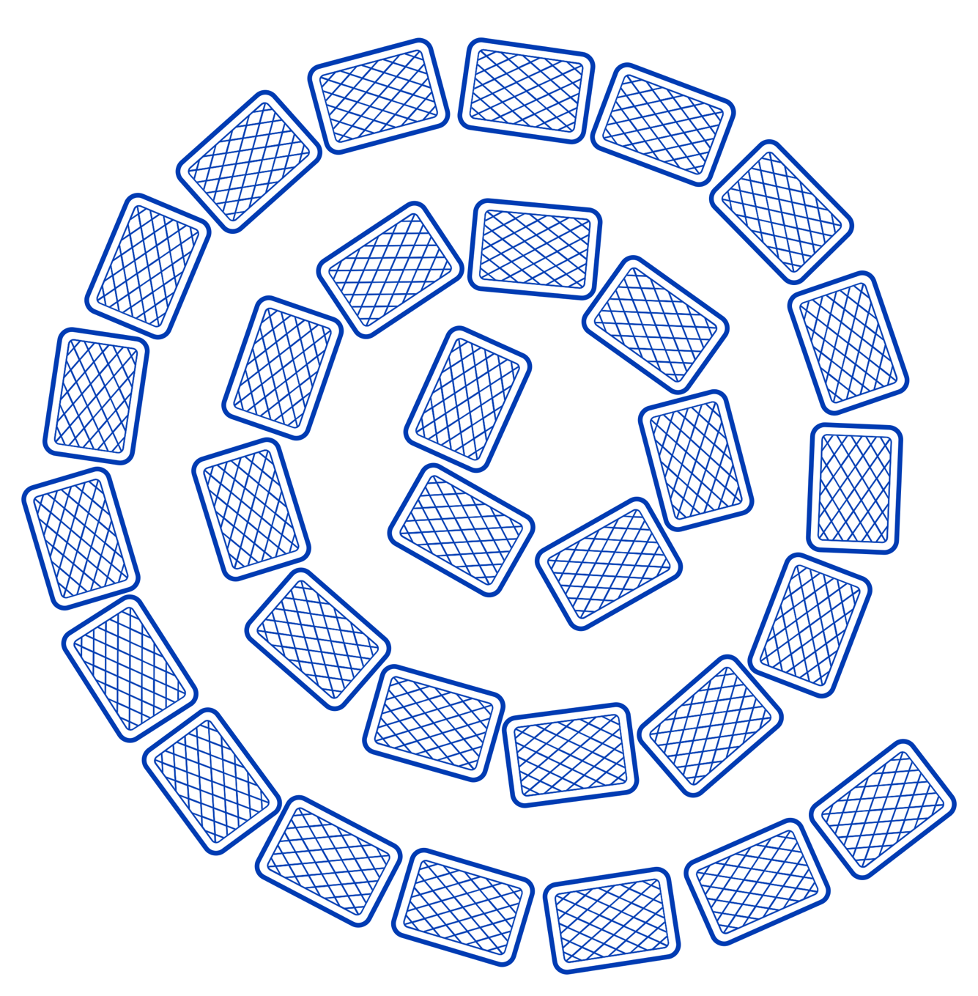

Skunk
Materials: Two 6-sided dice, paper or whiteboard for scoring
Players: 2 or more
Aim: To have the highest score after five rounds

Score is earned by adding the total of the two dice. If during a round, a player rolls a one
on either dice, they lose their points for that round and end their turn. If during a round,
a player rolls two ones, they also lose their entire accumulated score so far.

Instructions:
Decide who goes first.
Round one:
- Player 1 rolls two dice
- Player 1 adds the two numbers shown together. This is their current score for round one.
- Player 1 now has a choice: to roll the dice again or to pass.
- Rolling again gives the opportunity to increase their score for round one, by adding their resulting roll to their total. But it also is risky – if player 1 rolls a one, then they lose their score for this round.
- Player 1 can choose to roll again as often as they like. Their turn ends when either they pass, or they roll a one.
- Player 2 now rolls the two dice, totals their face value and has the same choice: roll again or pass.
- The round ends when every player has had their turn.
- Note down each player’s score at the end of round one.
Round two and onwards:
- Players turns proceed in the same order each round
- Players will need to be even more wary of rolling extra rolls each turn now, as they can lose all of their accumulated score if they roll double ones!
- At the end of each round, note each players score.
At the end of round five, total everyone’s scores across the rounds to find the winner.

Variations:
You can also play the game to try and get the lowest score at the end of five rounds. How does that change
your strategy?
You can also play to double your doubles! Every time you roll a double, you can double the total on the dice
(for example, if you roll a double 4, that would give you 16 points).

Target number
Materials: Two 6-sided dice (optional), paper or whiteboard to record (optional)
Players: 2
Aim: To be the first player to reach the target number.

Instructions:
Roll the dice to make a 2-digit number or choose a target number.
Set smaller target numbers for younger players, for example, between 10 and 20, 20 and 30.
Start at 0, and take turns to add 1, 2, 3 or 4 to the total. The player who reaches the target number wins the game.

For example:
Target number: 23
Player 1: ‘I choose 4.’
Player 2: ‘I choose 2, so the total is now 6.’
Player 1: ‘I choose 3, so the total is now 9.’
Player 2: ‘I choose 1, so the total is now 10.’
Player 1: ‘I choose 4, so the total is now 14.’
Player 2: ‘I choose 3, so the total is now 17.’
Player 1: ‘I choose 2, so the total is now 19.’
Player 2: ‘I choose 4, so the total is now 23.’
Player 2 has won the round.

Play several times using the same target number. Can you find a winning strategy?

Extension:
Now try changing the range of numbers you can add. Can you adapt your strategy again?

Square it
Materials: Dots game board, coloured pencils (a different colour for each player)
Players: 2

Instructions:
- Take turns choosing a dot on the board.
- The first player to choose four dots that can be joined to form a square is the winner.
- Squares can be any size or rotation.
Play a few rounds to test out your strategies!
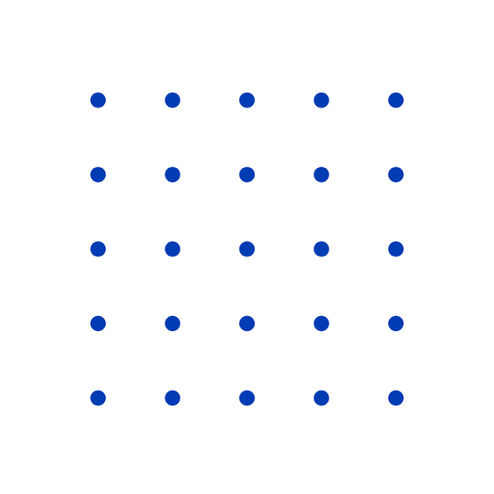

Frogs and toads
Players: 2
Materials: Game board, frogs and toads (or counters of two different colours),
paper or whiteboard for recording

Instructions:
- One player is ‘frogs’ and the other player is ‘toads.’
- Start with two frogs and two toads set up at opposite ends of the gameboard (or use different-coloured counters, for example, red for frogs and blue for toads).
- Take turns moving your frog or toad one space.
- Frogs and toads can step into an empty space.
- Frogs can jump over a toad into an empty space. Toads can jump over a frog into an empty space.
- Frogs cannot jump over more than one toad at a time. Toads cannot jump over more than one frog at a time.
- The challenge is to find a way to swap the frogs and toads to opposite sides without ever going backwards!
- How many moves does it take to solve the puzzle? Record the number of moves required to complete each round. Can you solve the puzzle with even less moves?
- Try the puzzle with three toads and three frogs!

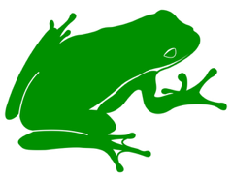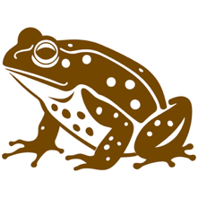

Treasure hunt
Players: 2
Materials: Counters (two colours for each player), empty grid map

Instructions:
Player 1 chooses coordinates for the treasure and marks it on their map with a counter.
Player 2 has to guess where the treasure is using the coordinates, marking their guess for each turn
on their grid map with a counter.
For each guess Player 2 makes, Player 1 tells them how many steps to get to the treasure.
For example:
On the map below, Player 2 guesses that the treasure is at coordinates C5. Player 1 tells Player 2
that the treasure is three steps away. Therefore, the treasure could be:
- three steps to the right at (F5)
- or it could be three steps up at (C8)
- or it could be two steps left and one step down at (A4).

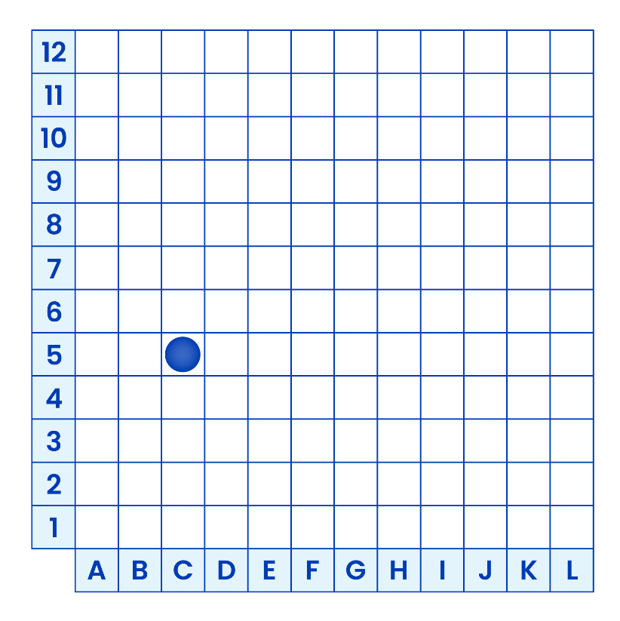

How many guesses do you need to find the treasure? What strategies can you use to find it quickly?
Switch turns to hide and locate the treasure.

Treasure hunt (cont'd)

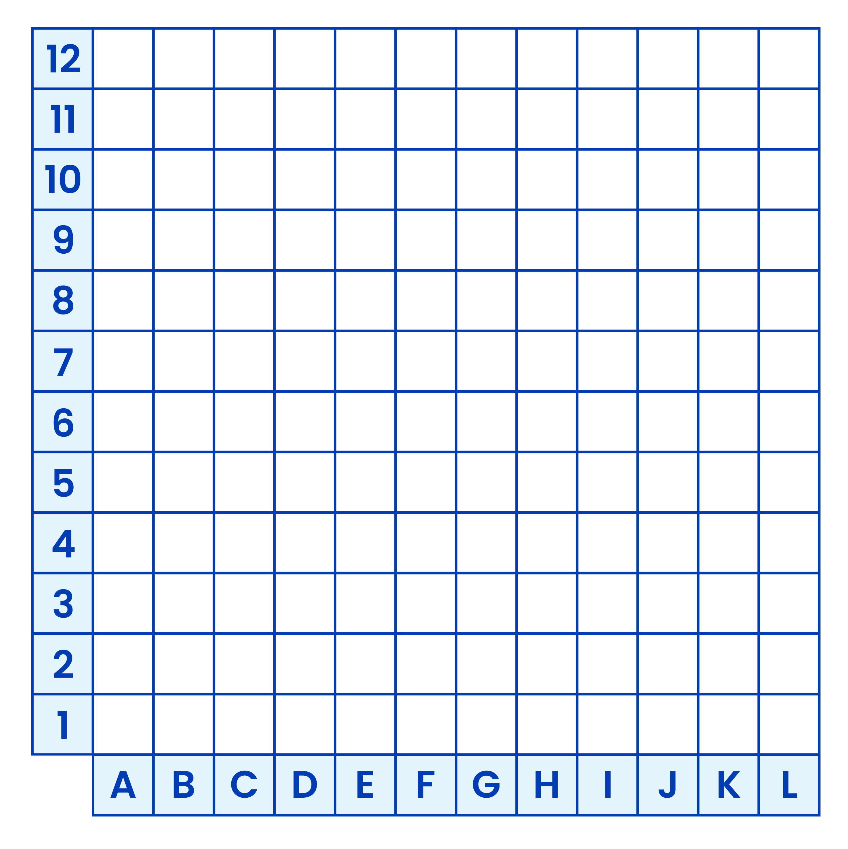

Hundreds chart jigsaw
Materials: Hundreds chart jigsaw pieces

Instructions:
Complete the Hundred chart Jigsaw. What strategies could you use to help you? Do you notice any patterns that help you?
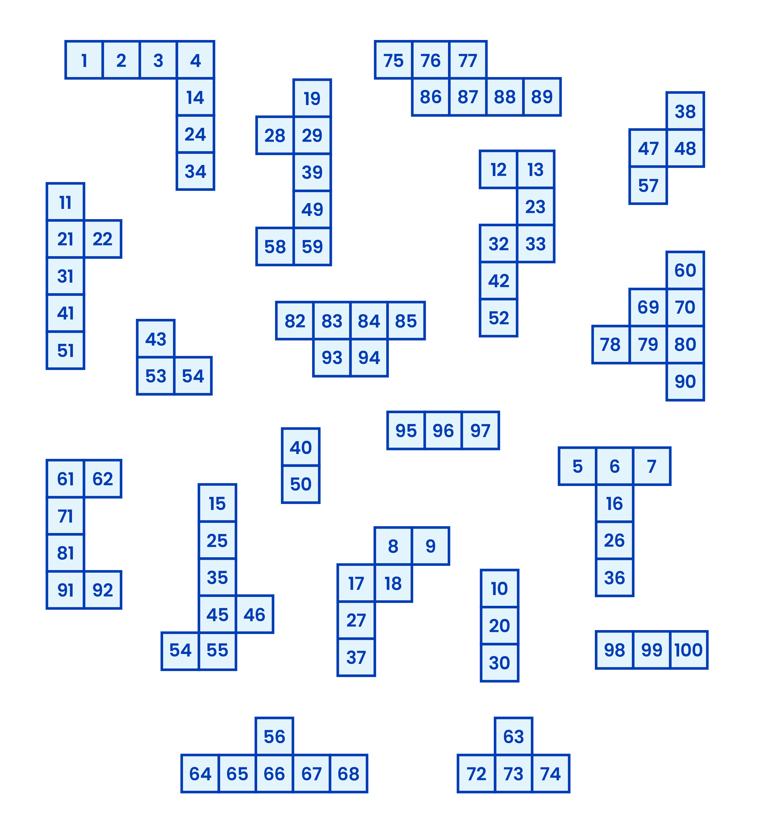

Art gallery problem
Materials: Gallery shapes, pencils
Players: Any

Instructions:
Imagine you're in an art gallery filled with amazing artwork. The gallery is not shaped as a rectangle or square as usual, but its floor plan has a fancy shape with lots of corners and twists. The shape is made up of straight lines that meet in corners (in mathematics it is called a polygon).
Your mission is to strategically place cameras at specific spots in the gallery to make sure that every spot in the gallery can be seen and is under surveillance. But here's the catch: you must use the smallest number of cameras possible, and these cameras can only be placed at the corners of the gallery. Your task is to place the smallest number of security cameras possible so that every single spot in the gallery is under surveillance.
This is known as the ‘art gallery problem’.
The mathematician Václav Chvátal proved in 1975 that the number of cameras equal to the quotient of the division of the number of sides by 3 is sufficient for any gallery.
As an example: for 3-sided galleries it would be 1 camera, for 6-sided galleries it would be 2 cameras, for 10-sided galleries it would be 3 cameras, for 23-sided galleries it would be 7.
Using a pencil, you can draw straight lines starting from the camera to trace the area the camera can see. Remember that it cannot see through walls. You can also trace the camera's line of sight with a ruler to see what the camera can cover.
Try these gallery shapes.

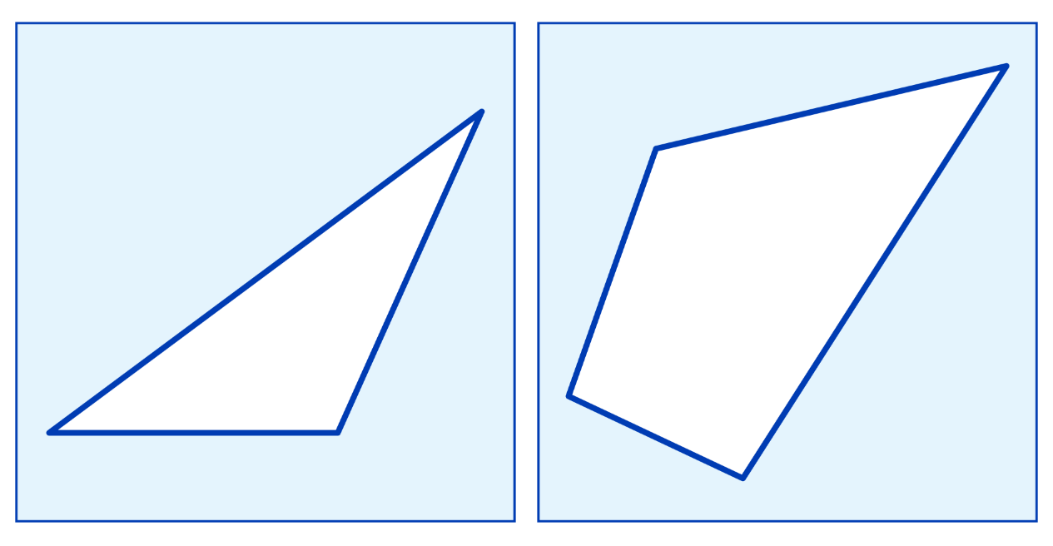

Art gallery problem (cont'd)

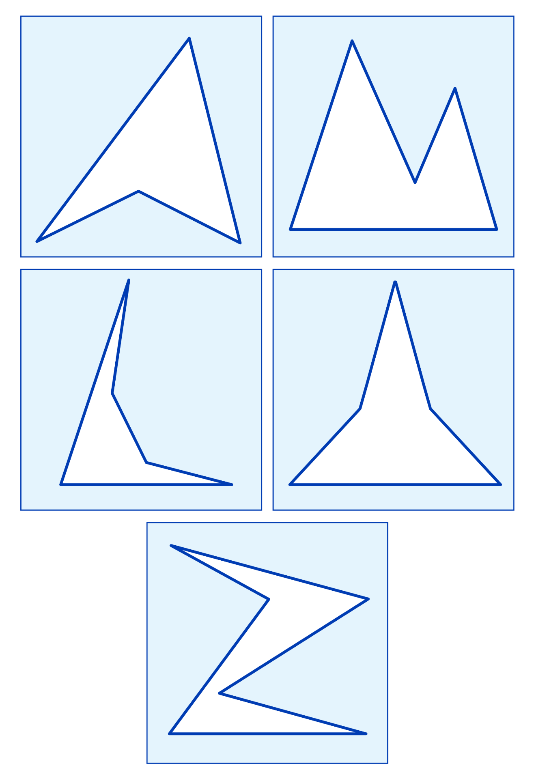

Bridges of Königsberg
Materials: Bridges of Königsberg maps, pencils
Players: Any

Instructions:
A river divides a town into separate areas connected by bridges. Is it possible to walk around the city crossing all the bridges exactly once (and not more than once)? You can start and finish anywhere, not necessarily in the same place. Try to find a valid route by drawing on the maps provided.

