Decimat worksheet

Name:

Class:
Use the cups and counters to model and represent each algebraic expression.

- Mark gets $3 less pocket money a week than his older brother Sam. Construct an expression to show much pocket money Mark gets.
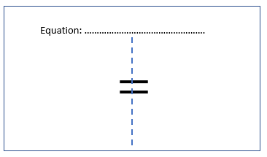

- I went shopping but don’t remember how much was in my wallet. I spent $2 at the toy store, and $4 at the shops. Construct an expression to show how much money I have left.

- I’m thinking of a mystery number and so is my friend. My mystery number is 5 more than my friend’s. Construct an expression to represent my mystery number.

- Phan has some money. Grace has $3 more. Construct an expression to show how much money Grace has.

- Freddie has several books. Shalla has twice as many. Construct an expression to show how many books Shalla has.

- Kellie has a little brother Angus. If you double Angus’s age and add on three more years, you get Kellie’s age. Construct an expression to show how old Kellie is.



