Rounding decimals reference
Use this strategy:
- Find the cut.
- Look at the digit to the right of the cut (hundredths).
- Use this digit to decide whether to round up or down.
Tip: 0 to 4 rounds down, and 5 to 9 rounds up.

Rounding to the nearest tenth
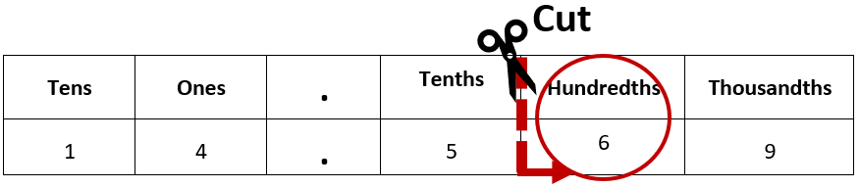
When rounding to the nearest tenth, 14.569 rounds to 14.6.

Rounding to the nearest hundredth

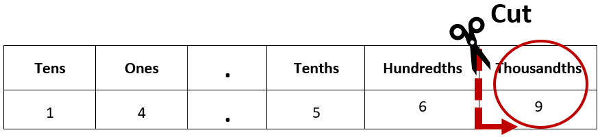
When rounding to the nearest hundredth, 14.569 rounds to 14.57.
