Data collection notes
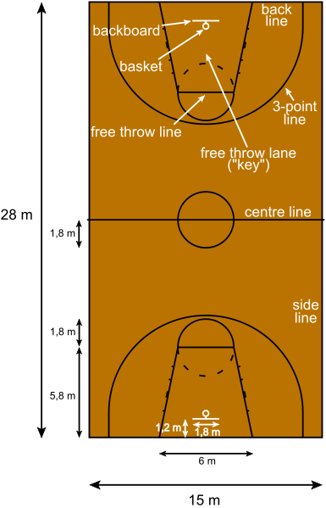
Image credit: NielsF CC BY-SA 3.0 DEED

Select six locations on the court with the following criteria.
One location must be very close to the basket (‘lay-up’)
Two locations must be beyond the three-point line (> 6.02m)
Hint: three-point shots are shortest when they are perpendicular from the basket and longest when they are straight ahead of the basket. Why is that?
The locations must cover a range of different distances from the basket.
Now draw a half-court diagram displaying your group’s locations and approximate distance from the basket/ring.

